Polytechnic University of Puerto Rico
Plasma Engineering Laboratory, 2026 Capstone Design Project
Plasma Reactor Monitoring and Supervisory Control System
User Manual – Node-RED Final
User manual: installation, operation and diagnostics
Version 1.0
October 6, 2026
System folder: Node-RED final

Revision history
Version | Date | Description | Author
1.0 | October 6, 2026 | Initial edition of the manual for the Node-RED final version. | Capstone Team 2026
This manual corresponds to the contents of the Node-RED final folder as of the date shown. Figures, channels, thresholds and messages were verified against the code of that version.
Table of contents
1. Introduction 10
1.1 Purpose 10
1.2 Scope 10
1.3 Audience 10
1.4 Conventions 10
1.5 About the screenshots 11
1.6 Documents in the folder 11
2. System overview 12
2.1 Main capabilities 12
2.2 Design limitations 12
3. Hardware and software architecture 13
3.1 Platform 13
3.2 Components and data flow 14
3.3 Shared state 15
3.4 Behavior when the backend does not respond 15
3.5 Backend modules 15
3.6 Node-RED in the system 16
4. Hardware connections and channel map 18
4.1 Pi-Plates stack 18
4.2 Relays 18
4.3 THERMOplate (address 2) 19
4.4 ADCplate (address 3) 19
4.5 DAQC2plate (address 4) 20
4.6 Aera DB9 connector (reserved) 20
5. Installation on the Raspberry Pi 22
5.1 Prepare Raspberry Pi OS and the network 22
5.2 Check Node.js and npm 22
5.3 Install Node.js and npm 22
5.4 Check Python and Pi-Plates 22
5.5 Enable SPI 22
5.6 Copy the project folder from a USB drive 23
5.7 Verify that the ports are free 23
5.8 Install the dependencies 23
5.9 First start 24
6. Starting the system 25
6.1 What npm start does 25
6.2 Messages of a successful start 26
6.3 Startup checklist 26
7. Accessing the interfaces 28
7.1 From the Raspberry Pi 28
7.2 Navigating between interfaces 28
7.3 From another computer (SSH tunnel) 28
7.4 Opening the Node-RED editor for the first time 29
8. Vacuum Controller guide 30
8.1 Colors and indicators 31
8.2 Additional information on hover 31
8.3 Data refresh 31
9. Reactor Dashboard guide 33
9.1 Top bar and connection status 34
9.2 Reactor diagram 35
10. Sensors and engineering conversions 37
10.1 Type K thermocouples 37
10.2 Room (DS18B20) 37
10.3 Water Temperature 37
10.4 Water, Coolant and Air Pressure 37
10.5 Medium Vacuum (Terranova 906A) 38
10.6 High Vacuum (Granville-Phillips 270) 38
10.7 Roughing Vacuum Gauges A/B 39
11. Manual Control 40
11.1 Operation 40
11.2 Locked controls 41
12. Manual control permission rules 42
12.1 Diffusion Pump A/B 42
12.2 Gate Valve A/B 42
12.3 Verification in the backend 43
13. Vacuum monitoring 45
14. Roughing Vacuum Gauges A/B 46
15. Charts and trends 48
15.1 Medium Vacuum chart 48
15.2 High Vacuum chart 48
15.3 Field Coil A/B trend 49
16. High Room Temperature alarm 50
17. Guided Startup sequence 52
17.1 Conditions to start 52
17.2 Starting 52
17.3 Sequence steps 53
17.4 Unmet conditions and failures 55
18. Guided normal Shutdown sequence 56
18.1 Procedure 56
18.2 Normal Shutdown and Emergency 57
19. Software Emergency 58
19.1 Stop actions 58
19.2 Scope of the software stop 60
20. Diagnostics and error handling 61
20.1 Where errors appear 61
20.2 Error codes 64
21. Technical logs 67
22. Functions reserved for future work 68
23. Shutting down the software correctly 70
24. Troubleshooting 71
25. Verification and validation status 73
25.1 Automated tests 73
26. Quick reference 75
27. Appendices 76
Appendix A. Backend API 76
Appendix B. Folder structure 76
Appendix C. Environment variables 77
Appendix D. Glossary 77
Appendix E. Maintaining the screens 77
List of figures
Figure 1. Architecture of the Node-RED final version: two Node-RED instances, a shared Python backend and the Pi-Plates stack. 14
Figure 2. Node-RED editor of instance 1 (/red): Vacuum Controller ui-template node, full-screen style and /api/* proxy flow with the 502 response. 15
Figure 3. Terminal output when running npm start (development computer; on the Raspberry Pi the paths begin with /home/<user>/Desktop). 26
Figure 4. Vacuum Controller: “Dashboard del reactor” link in the upper right corner and sequence panel. 28
Figure 5. Reactor Dashboard: “Vacuum Controller” link and status indicator in the top bar. 28
Figure 6. Complete Vacuum Controller with its numbered areas (illustrative values). 30
Figure 7. Complete Reactor Dashboard with its numbered areas (illustrative values). 33
Figure 8. Connection status and Diagnostics of the Reactor Dashboard. 34
Figure 9. Reactor diagram with readings and equipment states. 35
Figure 10. Manual Control panel with the service equipment, Diffuse Valves and Mechanical Pumps on. 40
Figure 11. Gate Valve A/B enabled: previous steps met, Diffusion Pumps on and hot, Chamber Valves off. 43
Figure 12. Medium Vacuum Gauge: current value, chart and S0 voltage. 45
Figure 13. High Vacuum Gauge: current value, chart and S1 voltage. 45
Figure 14. Vacuum Levels panel with the Rough Manifold A (S4) and Rough Manifold B (S5) bars. 46
Figure 15. Rough Manifold B out of range: the bar shows “Sin lectura” (no reading) and the ROUGH_RANGE error appears below. 47
Figure 16. High Vacuum without a valid reading: dotted horizontal line and VAC_GP270_STATE diagnostic. 48
Figure 17. Active alarm in the Vacuum Controller: Room box in red with “HIGH ROOM TEMPERATURE”. 50
Figure 18. Manual Control with the Buzzer (16) turned on by the alarm. 51
Figure 19. Active alarm in the Reactor Dashboard: top bar and Diagnostics. 51
Figure 20. Sequence panel at rest: Startup “Listo para iniciar” (ready to start) and Shutdown at step 1 of 16. 52
Figure 21. Startup in progress: step 2 of 22, 120 s wait with remaining time and list of steps. 52
Figure 22. Manual Control locked during the Startup. 53
Figure 23. Shutdown waiting for confirmation of the manual gas closure. 56
Figure 24. Shutdown in progress: step 2 of 16, 120 s wait and list of steps. 57
Figure 25. Emergency bar at rest. 58
Figure 26. Emergency active and confirmed: “PARO ACTIVADO. Relés OFF y consigna cero confirmados en las placas” (stop activated; relays OFF and zero setpoint confirmed on the boards). 58
Figure 27. Startup interrupted by an emergency. 58
Figure 28. Manual Control after Emergency: all relays OFF and controls locked. 59
Figure 29. The same Emergency state in the Reactor Dashboard. 60
Figure 30. Coolant thermocouple not responding: “Sin lectura” (no reading) and TEMP_READ error with its context. 61
Figure 31. Water Pressure with current outside 4–20 mA: value in yellow with the warning symbol (PRESS_RANGE). 62
Figure 32. Reactor Dashboard Diagnostics with PRESS_RANGE and VAC_GP270_STATE. 62
Figure 33. Manual Control with the backend stopped: NODE_RED_PROXY, “La orden no se confirmo” (the command was not confirmed) and relays in unknown state. 63
Figure 34. Reactor Dashboard with the backend stopped. 63
Figure 35. Manual Gas Flow Control (reserved). 68
Figure 36. Automatic Vacuum (reserved). 68
Figure 37. Gas Mass Flow Meter (reserved). 68
Figure 38. Terminal output when stopping the system with Ctrl+C: stop confirmed and flows stopped. 70
List of tables
Table 1. Manual conventions. 10
Table 2. Documents included in the Node-RED final folder. 11
Table 3. User interfaces. 12
Table 4. Software components. 13
Table 5. Services, ports and URLs. 14
Table 6. Backend Python modules. 15
Table 7. Node-RED instances. 16
Table 8. Boards in the stack and their use. 18
Table 9. RELAYplate2, address 0. 18
Table 10. RELAYplate2, address 1. 18
Table 11. Temperature channels. 19
Table 12. Voltage inputs (S). 19
Table 13. Current inputs (I). 20
Table 14. Aera Transformer DB9 connector (analog version). 20
Table 15. Processes started by npm start. 25
Table 16. Everyday addresses. 28
Table 17. Vacuum Controller areas. 30
Table 18. Meaning of colors and indicators. 31
Table 19. Polling frequency of each area. 31
Table 20. Reactor Dashboard areas. 33
Table 21. Top bar status indicator. 34
Table 22. Diagram readings. 35
Table 23. Water Temperature conversion. 37
Table 24. Pressure conversion examples. 37
Table 25. Medium Vacuum conversion examples. 38
Table 26. High Vacuum conversion examples. 39
Table 27. Manual switch-on rules. 42
Table 28. Conditions to turn on Gate Valve A/B. 42
Table 29. Vacuum sensors. 45
Table 30. Roughing Vacuum Gauges configuration. 46
Table 31. Roughing Vacuum Gauges errors. 47
Table 32. Vacuum chart characteristics. 48
Table 33. Field Coil A/B colors. 49
Table 34. Alarm logic with hysteresis. 50
Table 35. Startup steps. 53
Table 36. Startup states. 55
Table 37. Normal Shutdown steps. 56
Table 38. Differences between normal Shutdown and Emergency. 57
Table 39. Emergency messages. 59
Table 40. Location of error messages. 61
Table 41. System error codes. 64
Table 42. Technical log characteristics. 67
Table 43. Reserved functions. 69
Table 44. Common problems. 71
Table 45. Validation status by component. 73
Table 46. Main buttons. 75
Table 47. API routes. 76
Table 48. Main files of Node-RED final. 76
Table 49. npm start environment variables. 77
Table 50. Glossary. 77

1. Introduction

1.1 Purpose
This manual describes the installation, startup, operation and diagnostics of the Node-RED final version of the Plasma Reactor Monitoring and Supervisory Control System of the Plasma Engineering Laboratory at Polytechnic University of Puerto Rico. It is the official reference for reactor operators and technicians.

1.2 Scope
The system monitors and controls the vacuum subsystem and its auxiliary services from a Raspberry Pi equipped with Pi-Plates boards. It includes:
- Manual control of 16 relays, with permission rules based on the 2026 startup procedure.
- Guided Startup and normal Shutdown sequences.
- Software stop (Emergency) available in both interfaces.
- Readings from seven type K thermocouples, laboratory temperature (Room), water temperature, air, coolant and water pressures, Medium Vacuum, High Vacuum and the Roughing Vacuum Gauges A/B.
- High Room Temperature alarm that activates the Buzzer.
- Two web interfaces served by Node-RED: Vacuum Controller and Reactor Dashboard.
Outside the scope of this delivery are automatic vacuum regulation (Automatic Vacuum), operational control and measurement of the mass flow, control of the plasma sources, and historical storage of measurements in a database.

1.3 Audience
The manual is intended for reactor operators, laboratory technicians and students responsible for installing or maintaining the system. No programming knowledge is required; the technical sections point to the project files for readers who need more depth.

1.4 Conventions
Table 1. Manual conventions.
Element | Meaning
monospaced text | Terminal commands, files, paths, URLs and names of software elements.
Start Startup Process | Exact text of a button or message in the interface.
Note: | Supplementary information (word highlighted in light blue).
Warning: | Action or condition that may affect the equipment or safety (highlighted in yellow).
Physical validation pending: | Function implemented and tested in software that still has to be verified with the installed equipment (highlighted in yellow).
Verified in software: | Behavior confirmed by the software tests (highlighted in green).

1.5 About the screenshots
The screenshots in this manual were taken from the production interfaces of the Node-RED final folder, without modifying its code: the two Node-RED instances on ports 1880 and 1881 and the main.py backend on port 8000, started with npm start. They were taken on a development computer without Pi-Plates, where the board library was replaced by a test driver external to the project. The interfaces display their messages in Spanish; this manual quotes them as they appear on screen, with an English translation where helpful.
Warning: The numeric values shown in the screenshots are illustrative. They are not reactor measurements and do not constitute a physical validation.

1.6 Documents in the folder
Table 2. Documents included in the Node-RED final folder.
File | Contents
README.md | Summary of the Node-RED final version, startup and tests.
INSTALACION_PI.md | Preparing a new Raspberry Pi.
CONFIGURACION.md | Detailed configuration of boards, sensors and conversions.
CONEXIONES.md | Hardware connection map.
STARTUP_2026.md, SHUTDOWN_2026.md | Startup and normal shutdown sequences.
EMERGENCY_SHUTDOWN.md | Software stop and program shutdown.
PENDIENTES.md | Implementation status and pending validations.

2. System overview
The system separates the interface from hardware control. A single Python backend, main.py, reads the sensors, drives the relays and enforces all safety rules. Two Node-RED instances present the user interfaces and forward browser requests to the backend.
Table 3. User interfaces.
Interface | Function | Can operate equipment
Vacuum Controller (port 1880) | Manual control, Startup and Shutdown sequences, temperature, pressure and vacuum readings, charts and Vacuum Levels. | Yes: relays, sequences and Emergency.
Reactor Dashboard (port 1881) | Monitor with the reactor diagram: equipment status, readings in engineering units and diagnostics. | Emergency only.

2.1 Main capabilities
- Both interfaces share the same state: a command given in the Vacuum Controller is reflected in the Reactor Dashboard on the next refresh.
- Every manual command is validated in Python when it is received; disabling a button on screen is only a visual aid.
- Every relay is confirmed by reading the board state after the command.
- Invalid, stale or out-of-range readings are shown as errors; the system does not replace them with zero.
- Errors include a stable code and an indication of what to check.

2.2 Design limitations
- The software stop does not replace an independent physical stop. It does not act on a power loss or on forced termination of the process.
- A relay state indicates that the board output is energized; it does not confirm that the equipment started or the mechanical position of a valve.
- The charts keep only recent samples in the browser; the system does not store a measurement history.
- Automatic Vacuum, Manual Gas Flow Control and Gas Mass Flow Meter are reserved for future work and do not operate.

3. Hardware and software architecture

3.1 Platform
The platform configured for the project is a Raspberry Pi 4 Model B with 4 GB running Raspberry Pi OS with a stack of Pi-Plates boards communicating over SPI. Table 4 summarizes the software.
Table 4. Software components.
Component | Version / source | Function
Python 3 | Operating system | Runs main.py and the control modules.
Pi-Plates | Python package installed on the Pi | Library for the RELAYplate2, THERMOplate, ADCplate and DAQC2plate boards.
Node.js and npm | Version 18 or later | Run Node-RED and the launch.js launcher.
Node-RED | 4.1.15 (pinned in package-lock.json) | Serves the interfaces and the /api/* proxy.
FlowFuse Dashboard 2 (@flowfuse/node-red-dashboard) | 1.32.0 | Hosts each screen in a ui-template node.
Express | 4.x | HTTP server of each Node-RED instance.

Note: Node-RED is installed inside the project folder with npm ci (the node_modules folder). Neither a global Node-RED installation nor the system nodered service is used.

3.2 Components and data flow
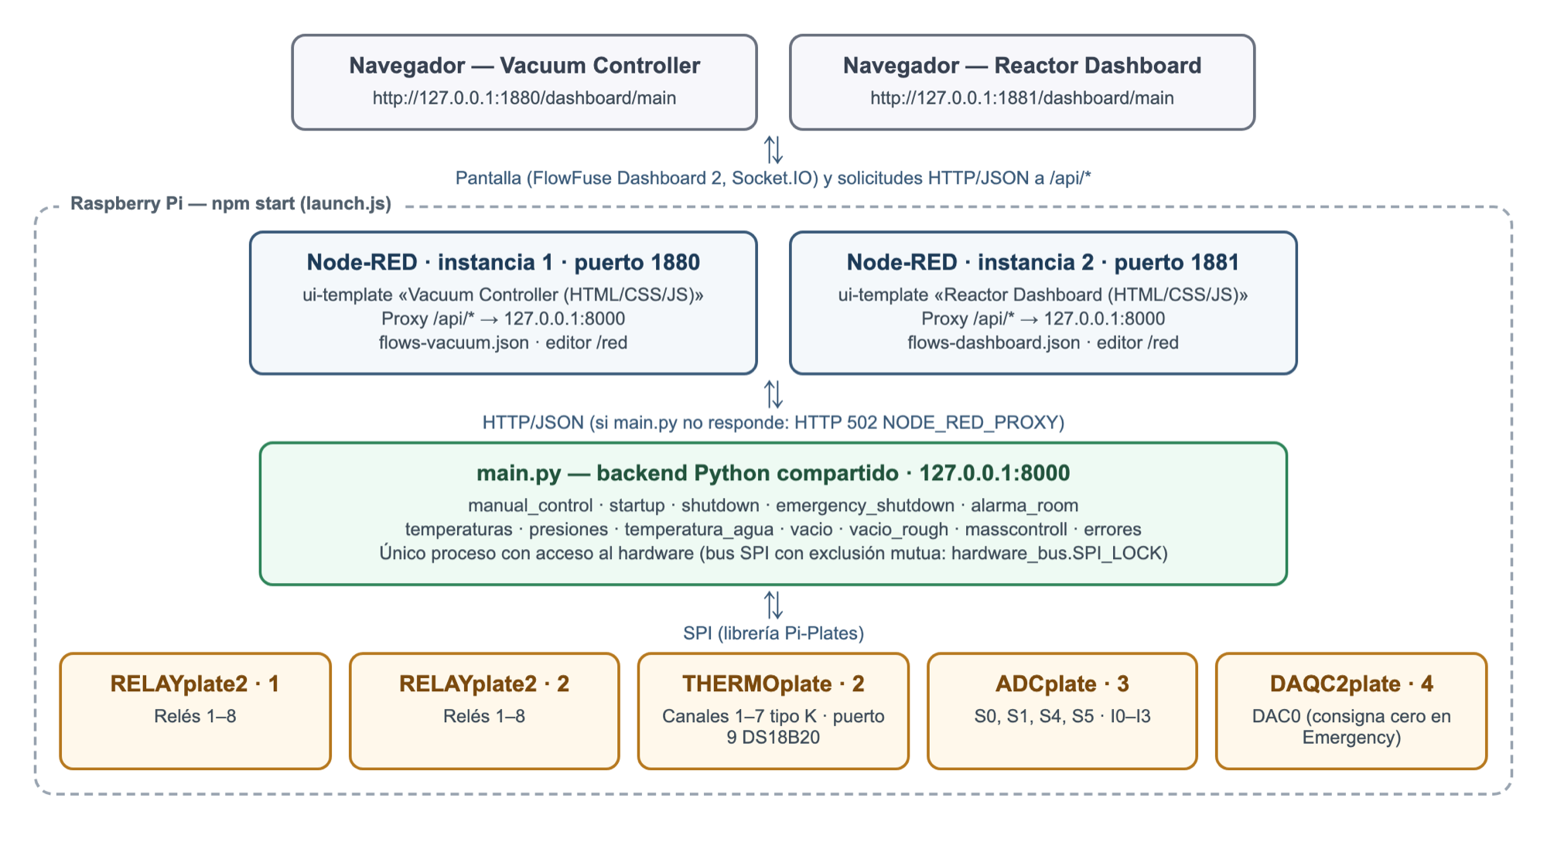
Figure 1. Architecture of the Node-RED final version: two Node-RED instances, a shared Python backend and the Pi-Plates stack.
Figure 1 shows the data flow. The browser loads the screen from Node-RED and periodically queries the /api/* routes of the same instance. Node-RED forwards each request to main.py at 127.0.0.1:8000 and returns the JSON response to the browser. Only main.py accesses the hardware; the Node-RED interfaces never access the Pi-Plates directly.
Table 5. Services, ports and URLs.
Service | Port | Local URL | Purpose
Python backend (main.py) | 8000 | http://127.0.0.1:8000 | JSON API and hardware access. It is not the operating interface.
Vacuum Controller (Node-RED, instance 1) | 1880 | http://127.0.0.1:1880/dashboard/main | Operating interface.
Reactor Dashboard (Node-RED, instance 2) | 1881 | http://127.0.0.1:1881/dashboard/main | Reactor monitor.
Node-RED editor, instance 1 | 1880 | http://127.0.0.1:1880/red | Editing the Vacuum Controller flows.
Node-RED editor, instance 2 | 1881 | http://127.0.0.1:1881/red | Editing the Reactor Dashboard flows.

All services listen only on 127.0.0.1. From another computer, access is through an SSH tunnel (section 7.3). The / address of each instance redirects to /dashboard/main.

3.3 Shared state
The backend keeps a single state for relays, sequences, Emergency and alarm. Both instances query that same state, so the two interfaces always show the same reactor situation. Temperature and ADCplate readings are cached for 1 s so that the SPI bus is not overloaded when several screens query at the same time.

3.4 Behavior when the backend does not respond
Each Node-RED instance contains the proxy flow shown in Figure 2. If main.py does not respond, the Sin respuesta de main.py → 502 node returns HTTP 502 with code NODE_RED_PROXY and the message “Sin respuesta de main.py (127.0.0.1:8000). La orden no se confirmo.” (no response from main.py; the command was not confirmed). The interface then shows the relays in unknown state and does not claim that a command was applied.
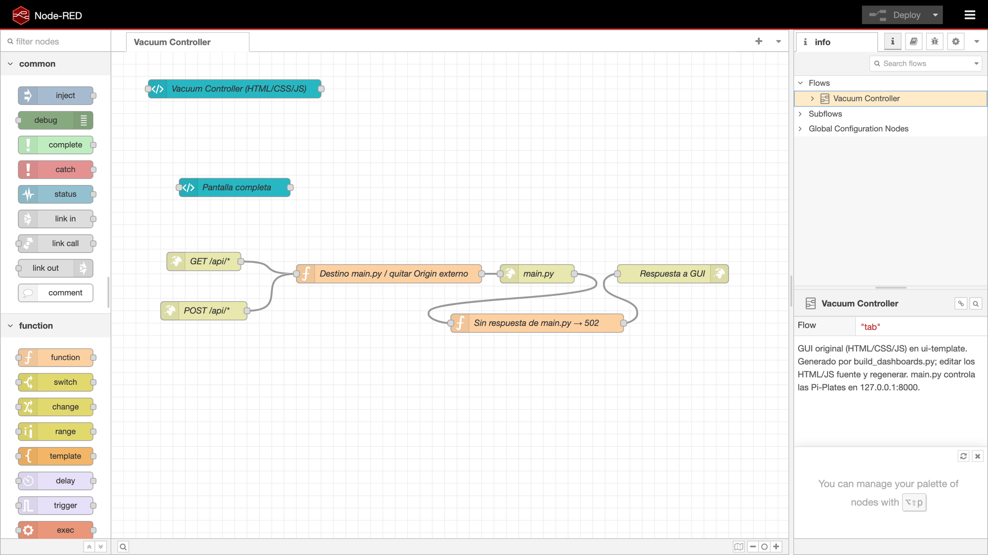
Figure 2. Node-RED editor of instance 1 (/red): Vacuum Controller ui-template node, full-screen style and /api/* proxy flow with the 502 response.

3.5 Backend modules
Table 6. Backend Python modules.
File | Responsibility
main.py | API HTTP server, startup, technical log and shutdown on exit.
manual_control.py | Relay map, reading and confirmation of states, manual permission rules.
startup.py / shutdown.py | Guided Startup and normal Shutdown sequences.
emergency_shutdown.py | Latched software stop.
alarma_room.py | High Room Temperature alarm.
temperaturas.py | Type K thermocouples and Room sensor (THERMOplate).
presiones.py | Air/Coolant/Water pressures; combines water, vacuum and Rough into /api/pressures.
temperatura_agua.py | Water temperature (4–20 mA transmitter).
vacio.py / vacio_rough.py | Medium and High Vacuum; Roughing Vacuum Gauges A/B.
masscontroll.py | Mass flow DAC0 setpoint; in this delivery it only sends zero during Emergency.
errores.py | Error codes and recommended actions.
hardware_bus.py | Mutual exclusion of the SPI bus (SPI_LOCK).

3.6 Node-RED in the system

Why there are two instances
Each interface runs in its own Node-RED instance, with its own port, flows (flows-vacuum.json or flows-dashboard.json) and internal data folder (.runtime/vacuum or .runtime/dashboard). This way each screen can be opened, edited or restarted without touching the other, and an error in the flows of one does not affect the other. Both depend on the same backend, so they do not duplicate hardware control.
Table 7. Node-RED instances.
Instance | Port | Flows | Contents
Vacuum Controller | 1880 | flows-vacuum.json | ui-template node “Vacuum Controller (HTML/CSS/JS)”, full-screen style and /api/* proxy.
Reactor Dashboard | 1881 | flows-dashboard.json | ui-template node “Reactor Dashboard (HTML/CSS/JS)”, full-screen style and /api/* proxy.

FlowFuse Dashboard 2 and ui-template
The screens use FlowFuse Dashboard 2 (@flowfuse/node-red-dashboard). Each one lives entirely (HTML, CSS and JavaScript) inside a single ui-template node, on the /dashboard/main page. Dashboard 2's own title bar and menu are hidden so that the screen fills the whole window.

API proxy and shared state
Each instance has the same proxy flow: the GET /api/* and POST /api/* nodes receive the browser request, the “Destino main.py / quitar Origin externo” node routes it to http://127.0.0.1:8000, the main.py node sends it and “Respuesta a GUI” returns the JSON. Because both instances talk to the same main.py, the two screens show the same state of relays, sequences, Emergency and alarm.

When the backend does not respond
If main.py does not answer, the “Sin respuesta de main.py → 502” node responds HTTP 502 with code NODE_RED_PROXY. The screens stay open, but show the relays as unknown and the readings as “Sin lectura” (no reading) (section 20). If main.py stops during normal operation, launch.js also closes both instances (section 6.1).

Navigation, ports and URLs
The ports and addresses are in Table 5. The links between screens are explained in section 7.2, and maintenance of the ui-template nodes in Appendix E.

4. Hardware connections and channel map
This chapter documents the assignments configured in the software. Board addresses, channels and relay numbers are not Raspberry Pi GPIO pin numbers. Change connections only with power removed.

4.1 Pi-Plates stack
Table 8. Boards in the stack and their use.
Board | Address | Use in the system
RELAYplate2 | 0 | Relays 1–8 (Table 9).
RELAYplate2 | 1 | Relays 1–8 (Table 10).
THERMOplate | 2 | Type K thermocouples (channels 1–7) and Room DS18B20 sensor (port 9).
ADCplate | 3 | 4–20 mA currents (I0–I3) and vacuum voltages (S0, S1, S4, S5).
DAQC2plate | 4 | DAC0: analog mass flow setpoint; in this delivery it is only set to zero during Emergency.

Physical validation pending: Positions of the address jumpers and physical orientation of the stack.

4.2 Relays
The “No.” column indicates the number each button shows in the Manual Control panel.
Table 9. RELAYplate2, address 0.
Relay | Equipment | No. on screen
1 | Air Compressor | 01
2 | Water Chiller | 02
3 | Booster Pump | 03
4 | Cool Trap A | 04
5 | Cool Trap B | 05
6 | Diffuse Valve A | 14
7 | Diffuse Valve B | 15
8 | Chamber Valve A | 06

Table 10. RELAYplate2, address 1.
Relay | Equipment | No. on screen
1 | Chamber Valve B | 07
2 | Mechanical Pump A | 08
3 | Mechanical Pump B | 09
4 | Diffusion Pump A | 10
5 | Diffusion Pump B | 11
6 | Gate Valve A | 12
7 | Gate Valve B | 13
8 | Buzzer | 16

Warning: The ON state of a relay confirms that the board output is energized. It does not confirm that the machine started or the physical position of a valve.

4.3 THERMOplate (address 2)
Table 11. Temperature channels.
Channel | Measurement | Sensor / configuration
1 | Coolant | Type K thermocouple
2 | Cool Trap A | Type K thermocouple
3 | Cool Trap B | Type K thermocouple
4 | Diffusion Pump A | Type K thermocouple
5 | Diffusion Pump B | Type K thermocouple
6 | Field Magnet A | Type K thermocouple
7 | Field Magnet B | Type K thermocouple
8 | Free | Unassigned
Port 9 | Room (lab temp) | Digital DS18B20; no setTYPE

Physical validation pending: Confirm that the installed probes are type K and check their polarity. Confirm the DS18B20 connection on port 9.

4.4 ADCplate (address 3)
Table 12. Voltage inputs (S).
Input | Signal | Conversion / use
S0 | Medium Vacuum (Terranova 906A) | P[Torr] = 10^(2V − 3)
S1 | High Vacuum (Granville-Phillips 270) | Nominal piecewise transfer, 0 to −5 V
S2, S3 | Free | Not applicable
S4 | Roughing Vacuum Gauge A | 0–10 V bar
S5 | Roughing Vacuum Gauge B | 0–10 V bar
S6 | Aera, flow output (DB9 pin 2) | Reserved; disabled in this delivery
S7 | Free | Not applicable

Table 13. Current inputs (I).
Input | Logical index | Measurement | Conversion
I0 | 12 | Water Temperature | T[°C] = (I − 4) × 6.25
I1 | 13 | Water Pressure | P[PSI] = max(0, (I − 4)/16 × 232)
I2 | 14 | Coolant Pressure | Same as I1
I3 | 15 | Air Pressure | Same as I1

Note: Logical index 12 for I0 is the channel number in the Pi-Plates library; it does not correspond to physical pin 12 of the Raspberry Pi.
Physical validation pending: Exact output and return pins on the connectors of the vacuum controllers and current transmitters.
Wiring of S4/S5 with their common, and label scales of the pressure transmitters (0–232 PSI).

4.5 DAQC2plate (address 4)
The DAC0 output is assigned to the Aera setpoint (DB9 pin 6). In this delivery, manual mass flow control is disabled: the system only writes 0 V to DAC0 as part of the Emergency stop and when main.py closes.

4.6 Aera DB9 connector (reserved)
The mass flow belongs to future work. Table 14 documents the connections planned in CONEXIONES.md, indicating their status.
Table 14. Aera Transformer DB9 connector (analog version).
Pin | Function | Connection | Status
1 | VALVE OPEN/CLOSED (override) | Not driven by the program | Pending: closing signal and override release
2 | OUTPUT 0–5 V (flow) | ADCplate 3, S6 | Reserved
3 | +15 VDC | External power supply | Prepared by the project team
4 | COMMON GND | Power common (0 V) | Confirmed
5 | −15 VDC | External power supply | Prepared by the project team
6 | CONTROL 0–5 V (setpoint) | DAQC2plate 4, DAC0 | Reserved; zero only during Emergency
7 | COMMON INPUT | DAQC2plate analog output common | Confirmed
8 | COMMON OUTPUT | ADCplate analog input common | Confirmed
9 | VALVE TEST POINT | Not connected | Confirmed

Physical validation pending: Normally open or normally closed variant of the Aera, and pin 1 configuration so that the device follows the pin 6 setpoint.

5. Installation on the Raspberry Pi
This procedure prepares a new Raspberry Pi. It is done only once per unit and requires an internet connection to install the dependencies. All commands are typed in a Raspberry Pi terminal, either directly or over SSH.

5.1 Prepare Raspberry Pi OS and the network
- Install Raspberry Pi OS with desktop on the microSD card and complete the initial setup (user, language, time zone).
- Connect the Raspberry Pi to the internet through Ethernet or Wi-Fi.
- Open Terminal from the desktop menu.

5.2 Check Node.js and npm
node -v
npm -v
If both commands show a version and node -v reports v18 or later, continue with section 5.4. If they answer command not found or the version is lower than 18, install Node.js as described in section 5.3.

5.3 Install Node.js and npm
sudo apt update
sudo apt install -y nodejs npm
node -v
npm -v
If the version installed by apt is lower than 18, install Node.js 22 from NodeSource:
curl -fsSL https://deb.nodesource.com/setup_22.x | sudo -E bash -
sudo apt install -y nodejs
node -v

5.4 Check Python and Pi-Plates
python3 --version
python3 -c "import piplates.RELAYplate2, piplates.THERMOplate, piplates.ADCplate, piplates.DAQC2plate; print('Pi-Plates OK')"
The second command must print Pi-Plates OK. If it fails, main.py does not start and shows the HW_IMPORT error. Install Pi-Plates in the same Python environment that will run main.py. If Pi-Plates is installed in a virtual environment, start the system with PYTHON=/path/to/venv/bin/python3 npm start.

5.5 Enable SPI
sudo raspi-config
- Select Interface Options.
- Select SPI.
- Answer Yes to enable it.
- Exit raspi-config and reboot the Raspberry Pi if the program asks you to.

5.6 Copy the project folder from a USB drive
The Node-RED final folder is delivered on a USB drive. It must be copied to the Raspberry Pi desktop before use.
Warning: Do not run the system directly from the USB drive. FAT32/exFAT file systems do not preserve the permissions or links in node_modules, and removing the drive would stop the system.
- Connect the USB drive to the Raspberry Pi.
- Locate the USB drive (it appears under /media/<user>/):
ls /media/$USER
ls "/media/$USER/USB_DRIVE_NAME"
Replace USB_DRIVE_NAME with the name shown by the first command. Copy the folder to the desktop:
cp -r "/media/$USER/USB_DRIVE_NAME/Node-RED final" "$HOME/Desktop/"
sync
If the folder was delivered compressed as node-red-final.tar.gz, extract it on the desktop:
cd "$HOME/Desktop"
tar -xzf "/media/$USER/USB_DRIVE_NAME/node-red-final.tar.gz"
Eject the USB drive from the desktop and enter the folder:
cd "$HOME/Desktop/Node-RED final"
ls
The listing must include, among others, package.json, package-lock.json, launch.js, server.js, main.py, flows.json, flows-vacuum.json and flows-dashboard.json.

5.7 Verify that the ports are free
The system uses ports 8000, 1880 and 1881. Stop the global Node-RED service if it exists and check the ports:
sudo systemctl stop nodered 2>/dev/null; sudo systemctl disable nodered 2>/dev/null
ss -ltn | grep -E ':(8000|1880|1881) ' || echo "Ports free"
The result must be Ports free. If any port appears, close the program using it: another copy of the project, the simulation version or producto final/main.py.

5.8 Install the dependencies
cd "$HOME/Desktop/Node-RED final"
npm ci
npm ci deletes any existing node_modules folder and installs exactly the versions pinned in package-lock.json: Node-RED 4.1.15, FlowFuse Dashboard 2 1.32.0 and Express. It downloads about 230 MB and requires internet. npm audit or funding notices do not prevent operation. It only needs to be repeated if package-lock.json changes.
Note: To install on a Raspberry Pi without internet, run npm ci on a Raspberry Pi with internet and copy the complete folder, including node_modules, compressed as .tar.gz. On the target unit, run only npm start.

5.9 First start
npm start
Section 6 describes the messages that should appear. To stop the system, press Ctrl+C in the same terminal (section 23).

6. Starting the system

6.1 What npm start does
npm start runs launch.js, which starts three processes in the same terminal:
Table 15. Processes started by npm start.
Process | Internal command | Function
Backend | python3 main.py --port 8000 --no-browser | Verifies both RELAYplate2 boards and opens the API on 127.0.0.1:8000.
Node-RED vacuum | node server.js vacuum | Vacuum Controller on port 1880.
Node-RED dashboard | node server.js dashboard | Reactor Dashboard on port 1881.

With a graphical session, the Vacuum Controller opens in the Raspberry Pi browser after 8 seconds. To prevent this, use NO_BROWSER=1 npm start.
Warning: If any of the three processes ends, launch.js stops the other two and prints the message <proceso> termino (codigo N); cerrando todo. (process ended with code N; closing everything). For example, if Pi-Plates is missing or a board does not respond, main.py ends with HW_IMPORT or HW_ID and the whole system stops.

6.2 Messages of a successful start
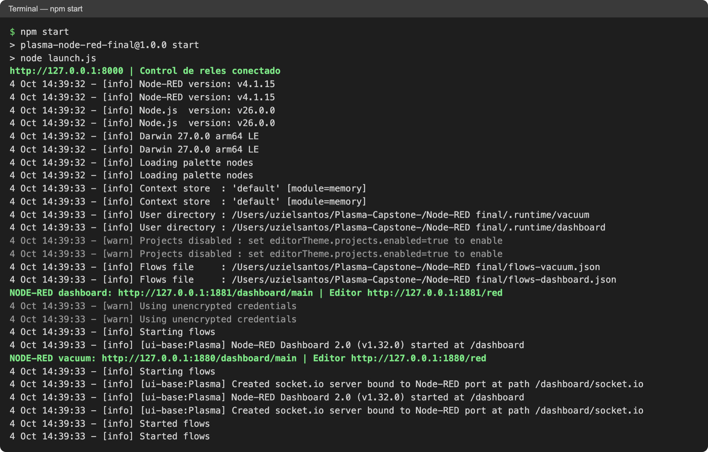
Figure 3. Terminal output when running npm start (development computer; on the Raspberry Pi the paths begin with /home/<user>/Desktop).
The following must appear in Figure 3, in this order:
- http://127.0.0.1:8000 | Control de reles conectado: main.py identified the relay boards and its API is available.
- NODE-RED dashboard: http://127.0.0.1:1881/dashboard/main | Editor http://127.0.0.1:1881/red.
- NODE-RED vacuum: http://127.0.0.1:1880/dashboard/main | Editor http://127.0.0.1:1880/red.
- Two Flows file lines showing flows-vacuum.json and flows-dashboard.json.
- Two Started flows lines.
The [warn] Projects disabled and Using unencrypted credentials notices are normal in this configuration. During operation, the terminal shows one line for each HTTP request handled by main.py, for example "GET /api/relays HTTP/1.1" 200.

6.3 Startup checklist
- The terminal shows the three service lines (Figure 3).
- The Vacuum Controller shows in Manual Control: Reles conectados — estado confirmado por las placas. (relays connected; state confirmed by the boards).
- The Temperatures panel shows Actualizado: <hora> (updated: <time>) under “Estado de temperaturas”.
- The Reactor Dashboard shows Monitor conectado (monitor connected) or lists the pending diagnostics.

7. Accessing the interfaces

7.1 From the Raspberry Pi
Open the desktop browser and type the addresses in Table 16.
Table 16. Everyday addresses.
Interface | Address
Vacuum Controller | http://127.0.0.1:1880/dashboard/main
Reactor Dashboard | http://127.0.0.1:1881/dashboard/main
Node-RED editor (Vacuum Controller) | http://127.0.0.1:1880/red
Node-RED editor (Reactor Dashboard) | http://127.0.0.1:1881/red

Warning: http://127.0.0.1:8000 is the backend. Do not use it as the operating interface: the official interface is the one served by Node-RED on ports 1880 and 1881. Do not open the .html files directly from the folder either: without the server there is no communication with the hardware.

7.2 Navigating between interfaces
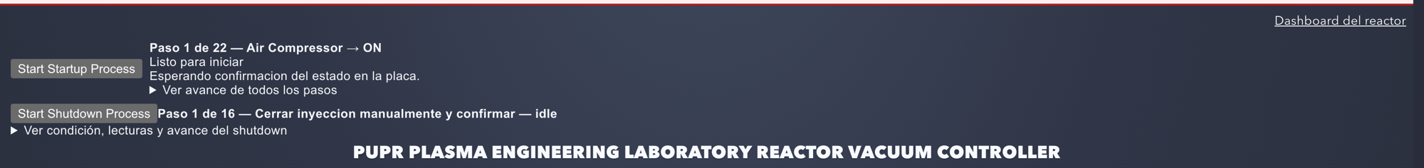
Figure 4. Vacuum Controller: “Dashboard del reactor” link in the upper right corner and sequence panel.
Figure 5. Reactor Dashboard: “Vacuum Controller” link and status indicator in the top bar.
The Dashboard del reactor link of the Vacuum Controller (Figure 4) opens the Reactor Dashboard, and the Vacuum Controller link of the Reactor Dashboard (Figure 5) goes back. Both links use the same host address as the open page and only change the port (between 1880 and 1881), so they also work through the SSH tunnel.

7.3 From another computer (SSH tunnel)
The services listen only on 127.0.0.1. To operate from another computer, open an SSH tunnel and use the same addresses in that computer's browser:
ssh -N -L 1880:127.0.0.1:1880 -L 1881:127.0.0.1:1881 -L 8000:127.0.0.1:8000 plasma@169.254.46.9
In this installation the Raspberry Pi is connected by direct Ethernet to the operating computer: user plasma, IP 169.254.46.9. If they change, replace them in the command. Port 8000 allows querying the backend (Appendix A) from that computer.
Keep that terminal open while using the interfaces. To close the tunnel, press Ctrl+C in it.
With the tunnel open, open http://localhost:1880/dashboard/main (Vacuum Controller) and http://localhost:1881/dashboard/main (Reactor Dashboard) in the computer's browser. The Raspberry Pi does not need to have the same time as the computer: the screens only check that the main.py readings keep updating.

7.4 Opening the Node-RED editor for the first time
The first time /red is opened, Node-RED 4.1 shows an update-notifications dialog and a welcome tour. They can be closed without affecting the system. The editor is used only for maintenance (Appendix E).

8. Vacuum Controller guide
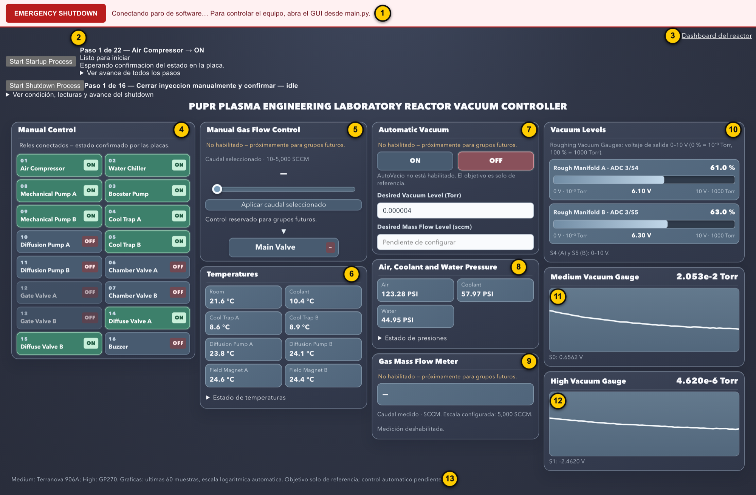
Figure 6. Complete Vacuum Controller with its numbered areas (illustrative values).
The Vacuum Controller (Figure 6) is the operating interface and opens at http://127.0.0.1:1880/dashboard/main. The numbers in the figure correspond to Table 17.
Table 17. Vacuum Controller areas.
No. | Area | Contents | Section
1 | Emergency bar (top, fixed) | EMERGENCY SHUTDOWN button and stop status. | 19
2 | Sequence panel | Start Startup Process, Start Shutdown Process, current step, conditions and progress. | 17 and 18
3 | “Dashboard del reactor” link | Opens the Reactor Dashboard. | 7.2
4 | Manual Control | 16 relay buttons with their state. | 11 and 12
5 | Manual Gas Flow Control | Reserved for future work. | 22
6 | Temperatures | Room and seven thermocouples. | 10 and 16
7 | Automatic Vacuum | Reserved for future work. | 22
8 | Air, Coolant and Water Pressure | Pressures in PSI. | 10
9 | Gas Mass Flow Meter | Reserved for future work. | 22
10 | Vacuum Levels | Rough Manifold A/B bars (0–10 V). | 14
11 | Medium Vacuum Gauge | Current value and trend chart. | 13 and 15
12 | High Vacuum Gauge | Current value and trend chart. | 13 and 15
13 | Bottom status line | Status of the vacuum readings. | 13

8.1 Colors and indicators
Table 18. Meaning of colors and indicators.
Indicator | Meaning
Green button with ON label | Relay energized, confirmed by the board.
Red OFF label | Relay de-energized, confirmed by the board.
— label | Unknown state: no confirmed communication with the boards.
Dimmed button | Command not allowed at this time; hovering shows the reason (section 12).
Whole panel dimmed | Manual control locked by a sequence in progress or by loss of communication.
Pressure value in yellow with warning symbol | Current outside 4–20 mA: the conversion is not reliable.
Red Room box | High Room Temperature alarm active.
Orange text “No habilitado — próximamente para grupos futuros” (not enabled; coming for future groups) | Reserved function; does not operate.
Dotted line in a chart | No valid data; it does not represent zero Torr.

8.2 Additional information on hover
Hovering over an element shows technical information: for relays, the reason for the permission or lock; for temperatures, the board and channel; for pressures, the current in mA; for vacuum values and the Rough bars, the channel and the voltage read.

8.3 Data refresh
Table 19. Polling frequency of each area.
Area | Query | Route
Manual Control | Every 2 s | GET /api/relays
Sequences | Every 1 s | GET /api/startup and GET /api/shutdown
Temperatures | Every 1.5 s | GET /api/temperatures
Pressures, vacuum, Rough | Every 1.5 s | GET /api/pressures
Emergency | Every 2 s | GET /api/emergency

Temperatures and pressures are rejected if the backend timestamp has not advanced for more than 15 s; in that case the interface shows “Sin lectura” (no reading) and a connection error. The check does not compare the Raspberry Pi clock with the clock of the computer displaying the page.

9. Reactor Dashboard guide
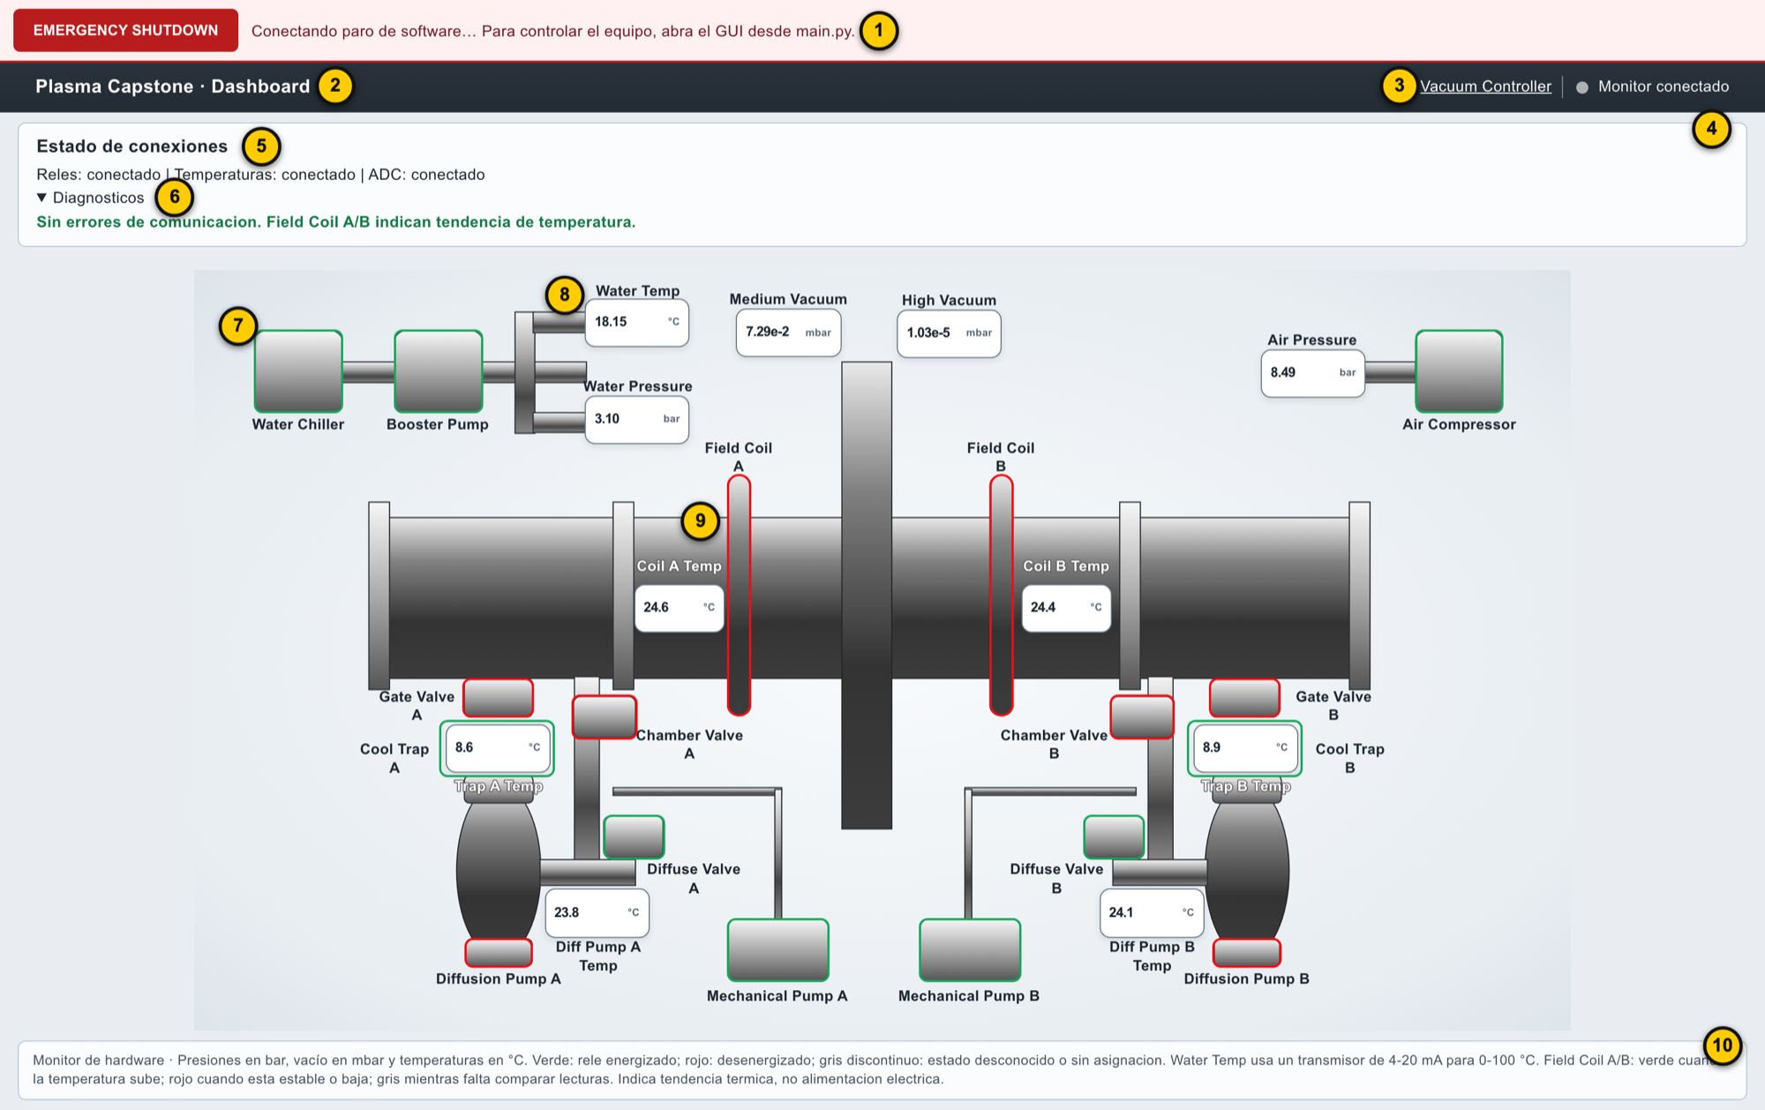
Figure 7. Complete Reactor Dashboard with its numbered areas (illustrative values).
The Reactor Dashboard (Figure 7) is the reactor monitor and opens at http://127.0.0.1:1881/dashboard/main. It does not operate relays or sequences. Its only action is the EMERGENCY SHUTDOWN button, which works the same as the one in the Vacuum Controller.
Table 20. Reactor Dashboard areas.
No. | Area | Contents
1 | Emergency bar | EMERGENCY SHUTDOWN button and stop status (section 19).
2 | Title | Plasma Capstone · Dashboard.
3 | “Vacuum Controller” link | Returns to the Vacuum Controller.
4 | Status indicator | General summary on the right of the top bar (Table 21).
5 | Connection status | Status of the Relays, Temperatures and ADC groups.
6 | Diagnostics | List of errors with their code.
7 | Equipment frame | Relay state: green, red or dashed gray.
8 | Reading | Value and unit of a sensor (Table 22).
9 | Field Coil A/B | Field Magnet A/B temperature trend (section 15.3).
10 | Bottom legend | Summary of units and colors.

9.1 Top bar and connection status
Figure 8. Connection status and Diagnostics of the Reactor Dashboard.
Table 21. Top bar status indicator.
Text | Meaning
Monitor conectado (monitor connected) | Relays, temperatures and ADC respond without errors.
Atencion: lecturas o estados pendientes (attention: pending readings or states) | At least one group reports an error; check Diagnostics.
ALARMA: HIGH ROOM TEMPERATURE | Laboratory temperature alarm active (section 16).

The “Estado de conexiones” (connection status) box (Figure 8) summarizes each group as “conectado” (connected) or “revisar diagnosticos” (check diagnostics). Expanding Diagnosticos lists the errors with their code.

9.2 Reactor diagram
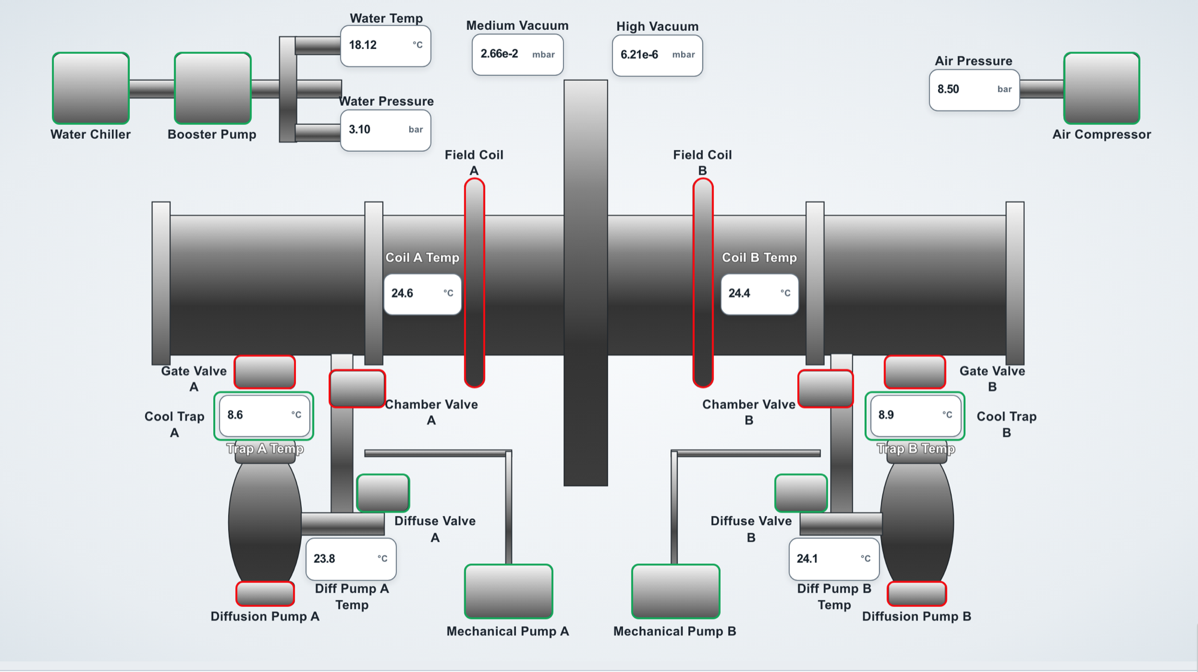
Figure 9. Reactor diagram with readings and equipment states.
Table 22. Diagram readings.
Label | Source | Unit and format
Water Temp | ADCplate 3 / I0 | °C, two decimals
Water Pressure | ADCplate 3 / I1 | bar, two decimals (PSI / 14.5037738)
Air Pressure | ADCplate 3 / I3 | bar, two decimals
Medium Vacuum | ADCplate 3 / S0 | mbar, exponential notation (Torr × 1.333223874)
High Vacuum | ADCplate 3 / S1 | mbar, exponential notation
Coil A / Coil B Temp | THERMOplate 2 / channels 6 and 7 (Field Magnet A/B) | °C, one decimal
Trap A / Trap B Temp | THERMOplate 2 / channels 2 and 3 | °C, one decimal
Diff Pump A / B Temp | THERMOplate 2 / channels 4 and 5 | °C, one decimal

The equipment frames show the relay state: green, energized; red, de-energized; dashed gray, unknown state. Field Coil A/B use different logic, based on the temperature trend (section 15.3). A reading with a yellow border and background indicates a pressure range warning.
Note: The Reactor Dashboard does not show Coolant Pressure or the Room temperature as diagram readings; both are shown in the Vacuum Controller. The Room alarm does appear in the Dashboard top bar.

10. Sensors and engineering conversions
This chapter documents the implemented formulas. The values in the example tables were calculated with the software's own functions.

10.1 Type K thermocouples
temperaturas.py configures the THERMOplate (address 2) with 60 Hz line-noise rejection and type K on channels 1 to 7. Each reading uses getTEMP(2, canal, 'c'), which returns degrees Celsius directly. A numeric, finite value within the type K conversion range of −200 to 1372 °C is accepted. This range validates the conversion; it is not an operating limit of the equipment. If a channel fails, only that channel shows “Sin lectura” (no reading) and its error.

10.2 Room (DS18B20)
The laboratory temperature is read from the DS18B20 connected to port 9 of the THERMOplate, address 2, with the same function getTEMP(2, 9, 'c'). Unlike channels 1–8, port 9 is not configured with setTYPE. The accepted range is the DS18B20 measuring range: −55 to 125 °C. The laboratory normally operates between 21 and 22 °C.

10.3 Water Temperature
Current transmitter on ADCplate 3 / I0. Formula: T [°C] = (I [mA] − 4) × 6.25. A current of 4 to 20 mA is accepted; outside that interval the value is rejected with WATER_TEMP_RANGE.
Table 23. Water Temperature conversion.
Current (mA) | Temperature (°C)
4 | 0
8 | 25
12 | 50
16 | 75
20 | 100

10.4 Water, Coolant and Air Pressure
4–20 mA transmitters on ADCplate 3: Water on I1, Coolant on I2 and Air on I3. Formula: P [PSI] = max(0, ((I [mA] − 4) / 16) × 232). The Reactor Dashboard converts to bar: P [bar] = P [PSI] / 14.5037738.
Table 24. Pressure conversion examples.
Current (mA) | PSI | bar | Indication
3.0 | 0.00 | 0.00 | PRESS_RANGE warning (less than 4 mA is shown as 0 PSI with a warning symbol)
4 | 0.00 | 0.00 | Normal
8 | 58.00 | 4.00 | Normal
12 | 116.00 | 8.00 | Normal
16 | 174.00 | 12.00 | Normal
20 | 232.00 | 16.00 | Normal
21 | 246.50 | 17.00 | PRESS_RANGE warning

Note: Outside 4–20 mA the value is shown in yellow with a warning symbol and its conversion is not reliable.

10.5 Medium Vacuum (Terranova 906A)
Analog output on ADCplate 3 / S0. Formulas: P [mTorr] = 10^(2V) and P [Torr] = 10^(2V − 3). Accepted: 0 V < V < 3 V. 0 V corresponds to the controller's LO state and approximately 3 V to OFF/HI; those values and negative ones are rejected with VAC_TN906_STATE and are not shown as pressure.
Table 25. Medium Vacuum conversion examples.
Voltage (V) | Torr | mTorr
0.25 | 3.162 × 10⁻³ | 3.162
0.50 | 1.000 × 10⁻² | 10
0.75 | 3.162 × 10⁻² | 31.62
1.00 | 0.1 | 100
1.50 | 1 | 1000
2.00 | 10 | 10 000
2.50 | 100 | 100 000
0, ≥ 3 or negative | VAC_TN906_STATE error | Not applicable

10.6 High Vacuum (Granville-Phillips 270)
GP270 Pressure output on ADCplate 3 / S1, with negative voltage. The software applies the nominal piecewise transfer from the GP270 manual, implemented in gp270_a_torr():
- Valid range: −5 V ≤ V < 0 V. The magnitude is defined as m = −V.
- Segment: n = max(0, min(4, ⌈m⌉ − 1)). An integer endpoint belongs to the previous segment (−1 V corresponds to 1 × 10⁻⁷ Torr).
- Pressure: P [Torr] = (m − n) × 10 × 10^(n − 8).
- −12 V to −10 V: invalid state (filament off or manual range), error VAC_GP270_STATE.
- Outside 0 to −5 V: error VAC_GP270_RANGE.
- 0 V does not mean perfect vacuum: error VAC_GP270_ZERO.
Table 26. High Vacuum conversion examples.
Voltage (V) | Pressure (Torr)
−0.5 | 5 × 10⁻⁸
−1.0 | 1 × 10⁻⁷
−1.5 | 5 × 10⁻⁷
−2.0 | 1 × 10⁻⁶
−2.4 | 4 × 10⁻⁶
−3.0 | 1 × 10⁻⁵
−3.5 | 5 × 10⁻⁵
−4.0 | 1 × 10⁻⁴
−4.5 | 5 × 10⁻⁴
−5.0 | 1 × 10⁻³
0.0 | VAC_GP270_ZERO error
−5.5 or positive | VAC_GP270_RANGE error
−10.5 | VAC_GP270_STATE error

Physical validation pending: Compare Medium and High with their controller panels at several points, especially at the GP270 decade changes (autorange).

10.7 Roughing Vacuum Gauges A/B
Rough A on ADCplate 3 / S4 and Rough B on S5. They are presented only as 0–10 V voltage bars. Chapter 14 documents their scale, tolerance and errors.

11. Manual Control
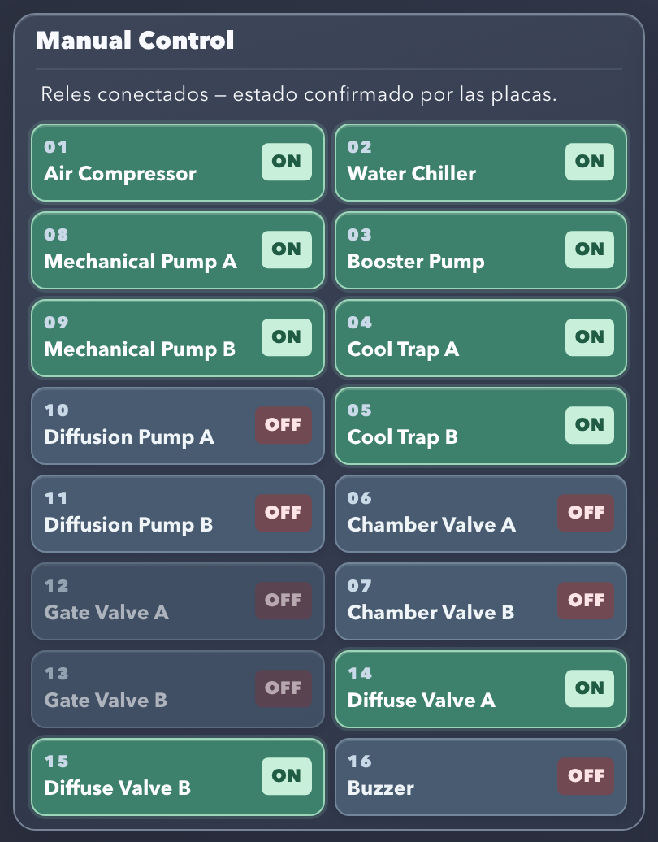
Figure 10. Manual Control panel with the service equipment, Diffuse Valves and Mechanical Pumps on.
The Manual Control panel (Figure 10) contains one button for each of the 16 relays. Each button shows the screen number, the equipment name and its state.

11.1 Operation
- Check that the panel shows Reles conectados — estado confirmado por las placas. (relays connected; state confirmed by the boards).
- Press the equipment button. The button toggles the current state: if it is OFF it requests ON, and if it is ON it requests OFF.
- While the command is processed, the panel shows Esperando confirmacion de la placa… (waiting for board confirmation) and all buttons are locked.
- The backend validates the command, sends it to the board and reads the resulting state. The button is updated only with the confirmed state.
If the command is not confirmed within 5 s, the interface shows NET_TIMEOUT and does not resend it automatically: the command may have been applied. Check the equipment before repeating it.
Warning: A dimmed button cannot be used at that moment. Hover over it to see the reason (section 12).

11.2 Locked controls
The whole panel is dimmed and does not accept commands while a Startup or Shutdown sequence is running, after an Emergency, or when communication with the backend is lost. The protection is also enforced in Python: a command received during those states is rejected with STARTUP_LOCKED, SHUTDOWN_LOCKED or STOP_LATCHED.

12. Manual control permission rules
The rules follow the 2026 startup procedure. They apply only to switching on (ON); switching off (OFF) is always allowed for all 16 relays, subject to the general locks in section 11.2.
Table 27. Manual switch-on rules.
Equipment | Address / relay | Rule for manual ON | OFF
Air Compressor | 0 / 1 | Always allowed | Allowed
Water Chiller | 0 / 2 | Always allowed | Allowed
Booster Pump | 0 / 3 | Always allowed (permanent) | Allowed
Cool Trap A / B | 0 / 4, 0 / 5 | Always allowed | Allowed
Mechanical Pump A / B | 1 / 2, 1 / 3 | Always allowed | Allowed
Diffuse Valve A / B | 0 / 6, 0 / 7 | On: Air Compressor, Water Chiller, Booster Pump, Cool Trap A and Cool Trap B | Allowed
Chamber Valve A / B | 0 / 8, 1 / 1 | The above plus Diffuse Valve A and Diffuse Valve B on | Allowed
Diffusion Pump A / B | 1 / 4, 1 / 5 | Medium Vacuum valid, without error, 3 s old or less and below 0.030 Torr | Allowed
Gate Valve A / B | 1 / 6, 1 / 7 | See section 12.2 | Allowed
Buzzer | 1 / 8 | Allowed (temporary permission) | Allowed

12.1 Diffusion Pump A/B
Switching on requires a Medium Vacuum reading that is numeric, finite, without error, 0 to 3 s old and with 0 < P < 0.030 Torr. Exactly 0.030 Torr does not enable switching on. If the pump is already on, OFF remains allowed even if the vacuum condition is lost. The system does not switch the pump off automatically.

12.2 Gate Valve A/B
Switching on either of the two Gate Valves requires all the previous steps of the procedure to be met:
Table 28. Conditions to turn on Gate Valve A/B.
Step | Condition
2–7 | On: Air Compressor, Water Chiller, Booster Pump, Cool Trap A/B, Diffuse Valve A/B
9 | On: Mechanical Pump A and B
11 | Medium Vacuum between 0.001 and 0.030 Torr, limits included
12 | On: Diffusion Pump A and B
13 | Both Diffusion Pumps between 250 and 300 °F (121.11–148.89 °C)
14 | Chamber Valve A and B off

The vacuum and temperature readings must be valid and 3 s old or less. If a condition is not met, the button's reason lists everything that is missing, for example: “Encendido bloqueado: falta apagar Chamber Valve A; Medium debe estar entre 0.001 y 0.030 Torr con lectura valida y reciente” (switch-on blocked: Chamber Valve A must be turned off; Medium must be between 0.001 and 0.030 Torr with a valid, recent reading).
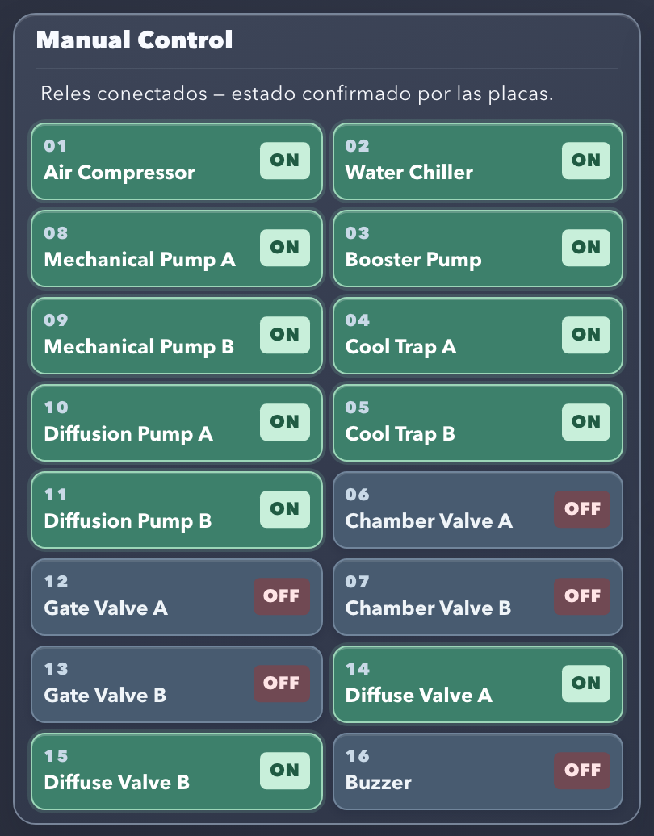
Figure 11. Gate Valve A/B enabled: previous steps met, Diffusion Pumps on and hot, Chamber Valves off.
Compare Figure 10, where Gate Valve A/B are dimmed, with Figure 11, where they already meet the conditions.
Note: Because the procedure is followed literally, manual switch-on of the Gate Valves is blocked if Medium drops below 0.001 Torr or if a Diffusion Pump exceeds 300 °F.

12.3 Verification in the backend
The rules are evaluated again in manual_control.py when each command is received, with readings updated at that moment. A request sent directly to the API, without going through the interface, receives the same validation and is rejected with code INPUT and the reason.
Warning: The conditions check the state recorded on the relay boards and the sensor readings. They do not check the 2-minute waits of the procedure or the physical response of each piece of equipment.

13. Vacuum monitoring
Vacuum is measured with two main sensors and two roughing vacuum indicators (Rough).
Table 29. Vacuum sensors.
Sensor | Input | Use in the system
Medium Vacuum (Terranova 906A) | ADCplate 3 / S0 | Reading and chart; condition for the Startup (step 14) and for manual permissions
High Vacuum (Granville-Phillips 270) | ADCplate 3 / S1 | Reading and chart
Roughing Vacuum Gauge A / B | ADCplate 3 / S4, S5 | Monitoring only, as voltage bars (chapter 14)

In the Vacuum Controller, each Medium/High card shows the value in Torr in exponential notation, for example 2.108e-2 Torr. Below the chart, the channel and the voltage read are shown, for example S0: 0.6619 V. If the reading is not valid, the card shows the voltage read (or “ADC sin datos”, no ADC data) and the reason for the error below the chart. The bottom status line summarizes the vacuum errors. In the Reactor Dashboard both values are shown in mbar.
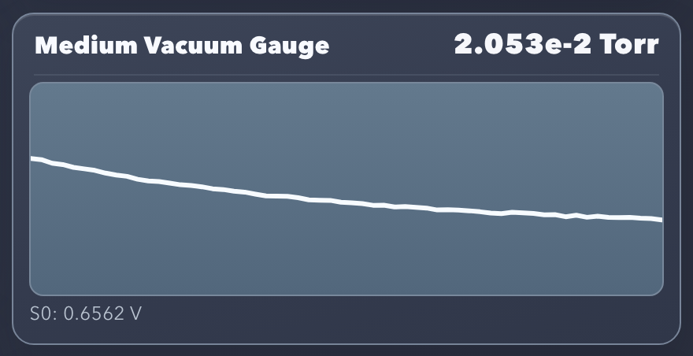
Figure 12. Medium Vacuum Gauge: current value, chart and S0 voltage.
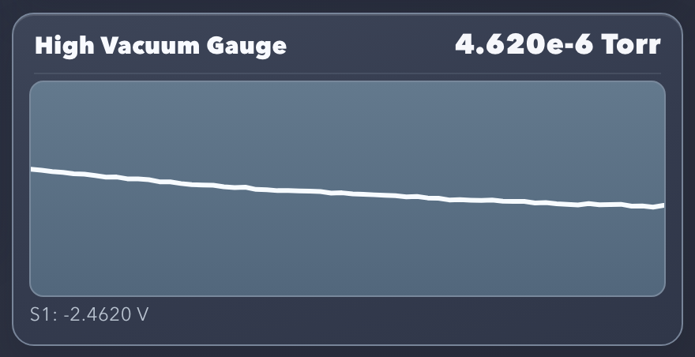
Figure 13. High Vacuum Gauge: current value, chart and S1 voltage.

14. Roughing Vacuum Gauges A/B
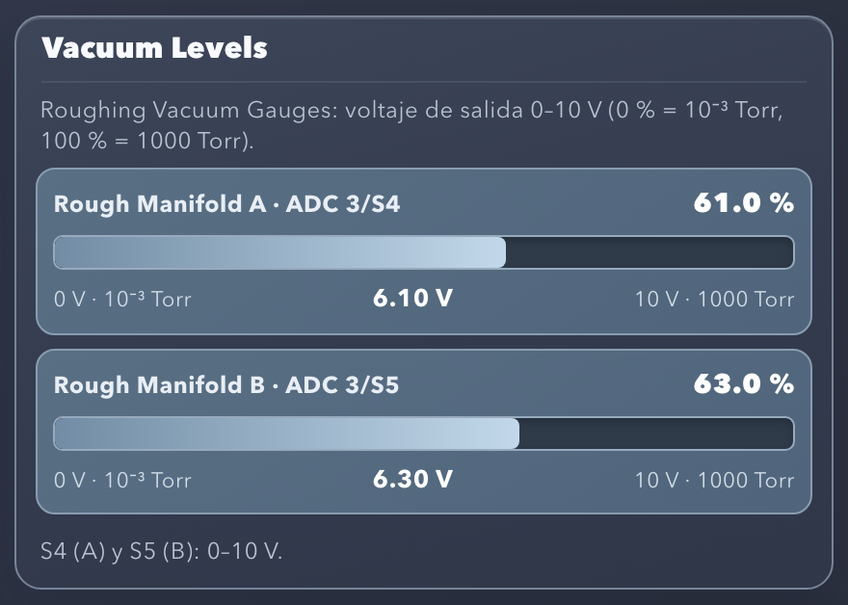
Figure 14. Vacuum Levels panel with the Rough Manifold A (S4) and Rough Manifold B (S5) bars.
The Vacuum Levels panel (Figure 14) shows the Roughing Vacuum Gauges A and B as voltage bars.
Table 30. Roughing Vacuum Gauges configuration.
Element | Value
Rough Manifold A | ADCplate 3 / S4
Rough Manifold B | ADCplate 3 / S5
Nominal sensor scale | 0 V = 0 % = 1 × 10⁻³ Torr; 10 V = 100 % = 1000 Torr
Displayed voltage | V_display = min(10, max(0, V_raw))
Bar percentage | Percentage = (V_display / 10) × 100
Accepted tolerance | −0.05 V to 10.05 V (ADC noise); the bar is limited to 0–100 %

Each bar shows the percentage (top right), the voltage read (center) and the labels at the ends of the scale: “0 V · 10⁻³ Torr” and “10 V · 1000 Torr”.
Warning: The system does not convert Rough A/B to Torr. The Torr labels only indicate the ends of the visual scale. Rough A/B are monitoring only: they do not affect the Startup, do not affect the Manual Control permissions and are not an input to Automatic Vacuum.
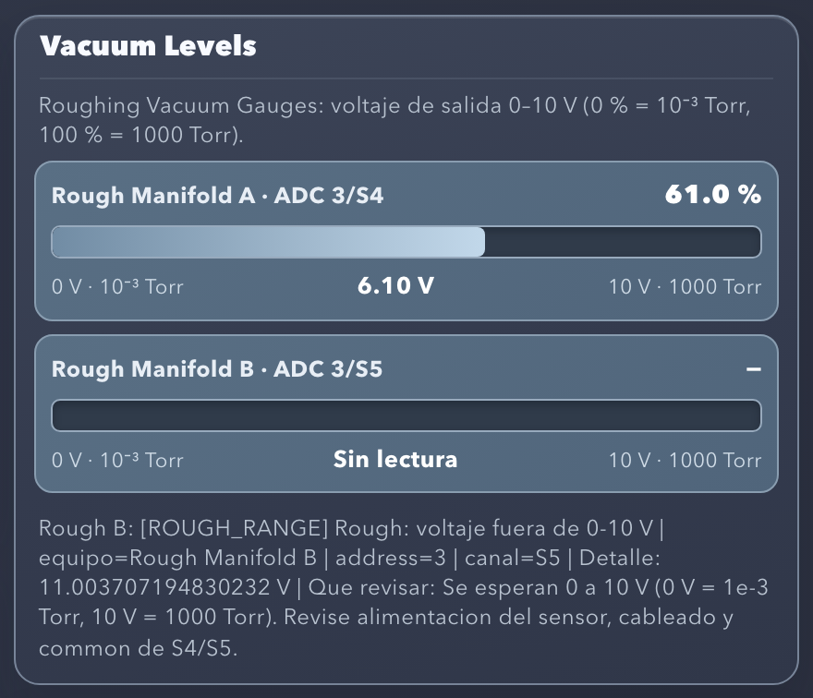
Figure 15. Rough Manifold B out of range: the bar shows “Sin lectura” (no reading) and the ROUGH_RANGE error appears below.
Table 31. Roughing Vacuum Gauges errors.
Code | Cause | Indication
ROUGH_RANGE | Voltage outside −0.05 to 10.05 V | Empty bar, “Sin lectura” (no reading) and details below the panel
ROUGH_READ | Read failure or ADCplate not available | Same
ROUGH_VALUE | Non-numeric value | Same

Figure 15 shows an example of an error.
Verified in software: Channels S4/S5, percentage calculation (2.5 V gives 25 % and 7.5 V gives 75 %), limits, tolerance and errors.
Physical validation pending: Confirm the S4/S5 wiring with their common and compare the voltage read by the ADC with the actual output of each sensor.

15. Charts and trends

15.1 Medium Vacuum chart
Table 32. Vacuum chart characteristics.
Characteristic | Medium Vacuum | High Vacuum
Sensor and input | Terranova 906A, ADCplate 3 / S0 | GP270, ADCplate 3 / S1
Value unit | Torr | Torr
Vertical axis | log₁₀(Torr), automatic scale | log₁₀(Torr), automatic scale
Refresh | Every 1.5 s; a new sample only when the backend timestamp changes | Same
Samples kept | Last 60 | Last 60

The vertical axis adjusts automatically between the minimum minus 0.5 and the maximum plus 0.5 decades of the visible samples, so the chart shows the trend; the exact value is read in the card header. Samples are plotted from left to right in order of arrival.

15.2 High Vacuum chart
It uses the same rules as the Medium chart. Its source is the GP270 Pressure output converted as described in section 10.6.
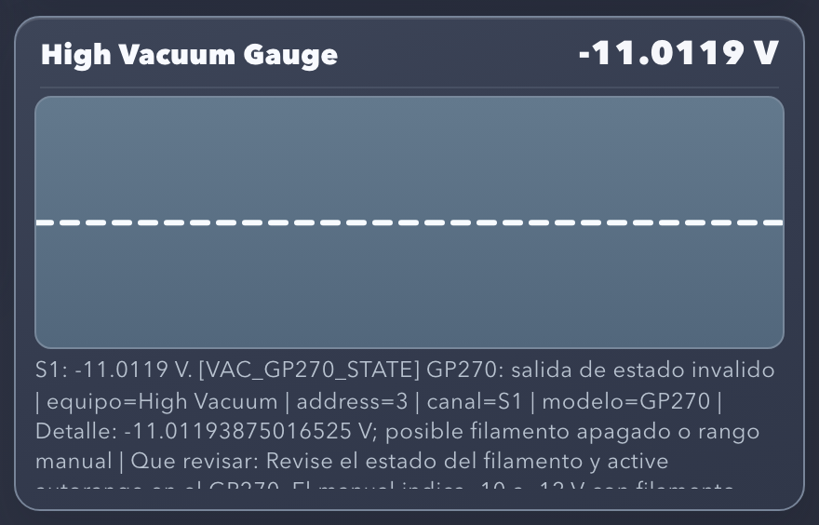
Figure 16. High Vacuum without a valid reading: dotted horizontal line and VAC_GP270_STATE diagnostic.
When the reading is not valid, the chart clears its history and draws a dotted horizontal line (Figure 16). That line indicates absence of data; it does not represent zero Torr. Samples are stored only in the browser: when the page is reloaded, the chart starts over. They are not a historical record or a database.

15.3 Field Coil A/B trend
In the Reactor Dashboard, the Field Coil A and Field Coil B frames show the temperature trend of Field Magnet A (THERMOplate 2, channel 6) and Field Magnet B (channel 7):
Table 33. Field Coil A/B colors.
Color | Condition
Green | The temperature rose between two new readings, compared at the visible resolution of 0.1 °C.
Red | The temperature stayed the same or dropped.
Dashed gray | No reading, or waiting for a second comparable reading.

Two readings are comparable if they are new and 15 s or less apart. An error restarts the comparison.
Warning: The Field Coil indicator is a thermal trend. It does not confirm the electrical supply of the coils, does not drive relays and is not an interlock.

16. High Room Temperature alarm
The alarm monitors the laboratory temperature measured by the DS18B20 on THERMOplate 2, port 9. The alarma_room.py module checks it every 2 s in the backend, even when no interface is open.
Table 34. Alarm logic with hysteresis.
Room temperature | Result
T > 29 °C | The alarm is activated and the Buzzer turns on.
28 °C < T ≤ 29 °C | The previous state is kept: it does not activate from normal and does not deactivate if it is already active.
T ≤ 28 °C | The alarm is deactivated and the Buzzer turns off, if the alarm turned it on.

- The Buzzer is relay 8 of the RELAYplate2 at address 1. Activation and return to normal are recorded in the technical log.
- Turning the Buzzer off manually from Manual Control silences the alarm while it remains active; the visual warning stays.
- If the Room reading fails, the alarm keeps its state and shows the sensor error.
- With Emergency active, the alarm does not drive the Buzzer, but the warning stays visible.
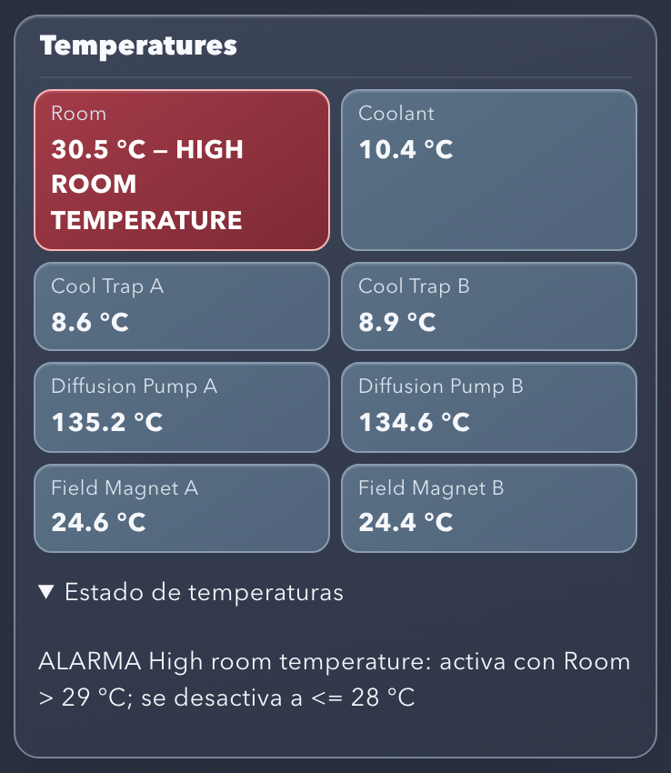
Figure 17. Active alarm in the Vacuum Controller: Room box in red with “HIGH ROOM TEMPERATURE”.
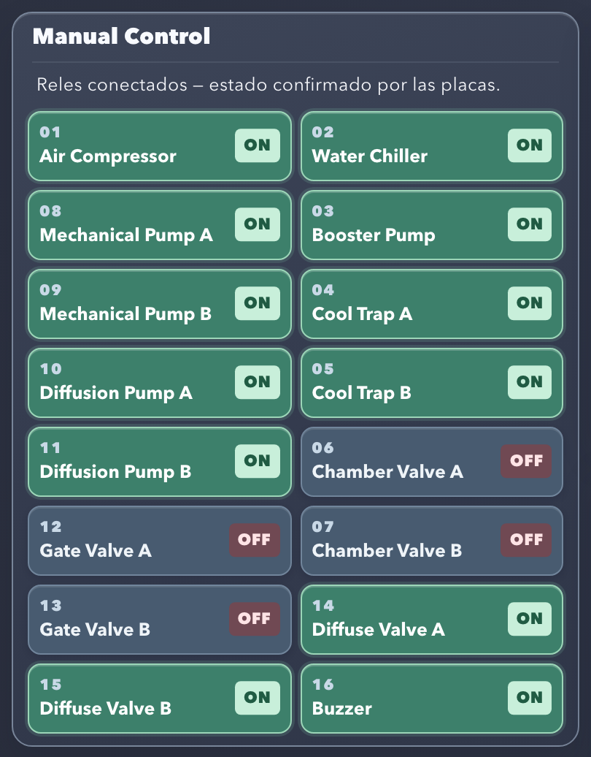
Figure 18. Manual Control with the Buzzer (16) turned on by the alarm.
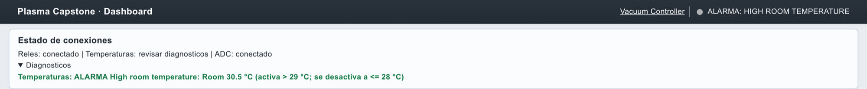
Figure 19. Active alarm in the Reactor Dashboard: top bar and Diagnostics.
In the Vacuum Controller, the Room box turns red and adds “HIGH ROOM TEMPERATURE” (Figure 17); the Buzzer appears on in Manual Control (Figure 18). In the Reactor Dashboard, the top bar shows ALARMA: HIGH ROOM TEMPERATURE and Diagnostics shows the reading with its thresholds (Figure 19).
Physical validation pending: Compare the DS18B20 reading with a reference thermometer and verify that the Buzzer sounds when the alarm activates.

17. Guided Startup sequence
The Startup sequence runs the steps of the 2026 startup procedure in order. It is controlled from the sequence panel of the Vacuum Controller.

17.1 Conditions to start
- The Startup is in the Listo para iniciar (ready to start) state and no Shutdown is in progress.
- Emergency is not active.
- The Startup runs only once per system start. To repeat it, stop the system with Ctrl+C and run npm start again.

17.2 Starting
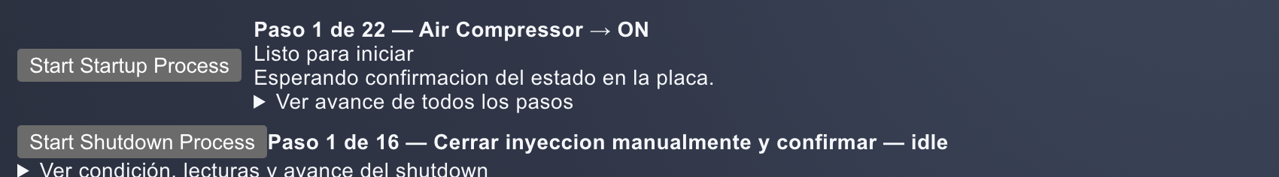
Figure 20. Sequence panel at rest: Startup “Listo para iniciar” (ready to start) and Shutdown at step 1 of 16.
- Press Start Startup Process.
- The Manual Control, Manual Gas Flow Control and Automatic Vacuum panels are locked. Readings keep updating and Emergency remains available.
- Expand Ver avance de todos los pasos (view progress of all steps) to see the complete list with each step's status: completed, current or pending.
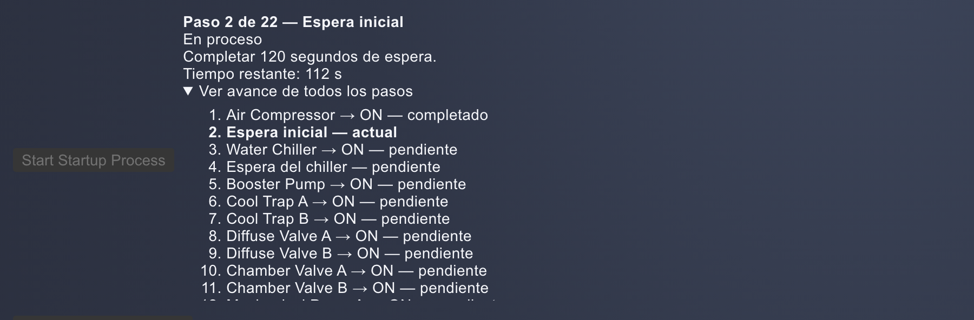
Figure 21. Startup in progress: step 2 of 22, 120 s wait with remaining time and list of steps.
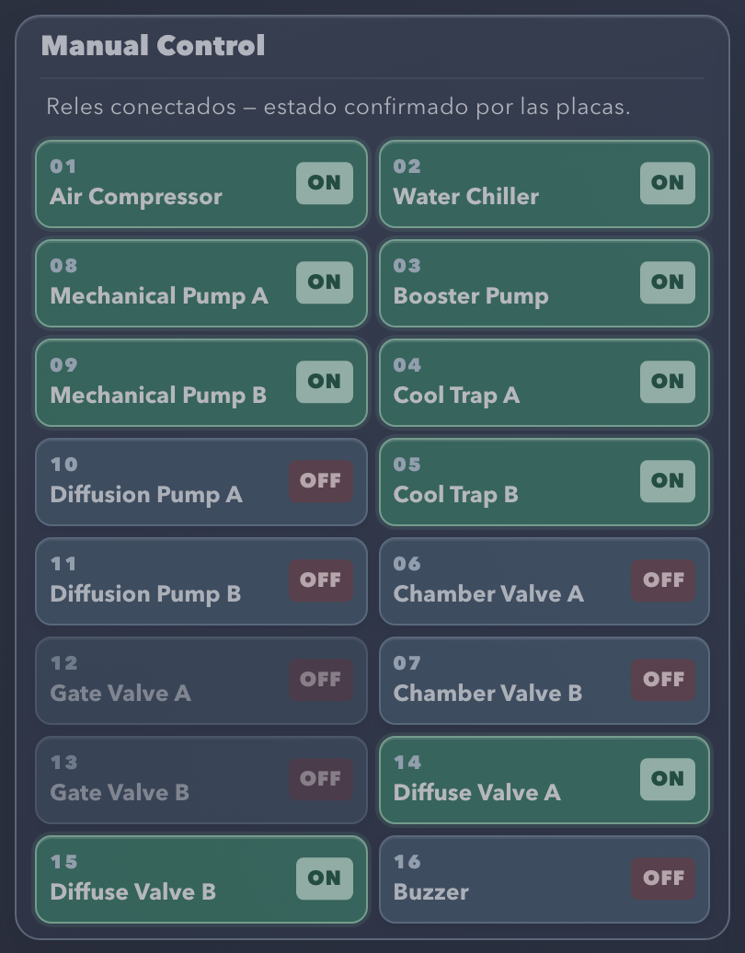
Figure 22. Manual Control locked during the Startup.

17.3 Sequence steps
The panel shows “Paso N de 22” (step N of 22), the step title, the status, the condition, the readings used and the remaining time of the waits (Figure 21).
Table 35. Startup steps.
Step | Action | Required condition | Operator action | Result
1 | Turn on Air Compressor | Confirmation of the state on the board | Press Start Startup Process | Advances on confirmation
2 | Initial wait | 120 s timed | None | Shows the remaining time
3 | Turn on Water Chiller | Confirmation of the state on the board | None | Advances on confirmation
4 | Chiller wait | 120 s timed | None | Shows the remaining time
5 | Turn on Booster Pump | Confirmation of the state on the board | None | Advances on confirmation
6 | Turn on Cool Trap A | Confirmation of the state on the board | None | Advances on confirmation
7 | Turn on Cool Trap B | Confirmation of the state on the board | None | Advances on confirmation
8 | Turn on Diffuse Valve A | Confirmation of the state on the board | None | Advances on confirmation
9 | Turn on Diffuse Valve B | Confirmation of the state on the board | None | Advances on confirmation
10 | Turn on Chamber Valve A | Confirmation of the state on the board | None | Advances on confirmation
11 | Turn on Chamber Valve B | Confirmation of the state on the board | None | Advances on confirmation
12 | Turn on Mechanical Pump A | Confirmation of the state on the board | None | Advances on confirmation
13 | Turn on Mechanical Pump B | Confirmation of the state on the board | None | Advances on confirmation
14 | Wait for Medium Vacuum | Medium between 1 × 10⁻³ and 3 × 10⁻² Torr (limits included); valid reading 15 s old or less | Wait for pump-down | Wait with no time limit
15 | Turn on Diffusion Pump A | Confirmation of the state on the board | None | Advances on confirmation
16 | Turn on Diffusion Pump B | Confirmation of the state on the board | None | Advances on confirmation
17 | Wait for the temperature of both Diffusion Pumps | Both between 250 and 300 °F (121.11–148.89 °C); valid readings 15 s old or less | Wait for warm-up | Wait with no time limit
18 | Turn off Chamber Valve A | Confirmation of the state on the board | None | Advances on confirmation
19 | Turn off Chamber Valve B | Confirmation of the state on the board | None | Advances on confirmation
20 | Turn on Gate Valve A | Confirmation of the state on the board | None | Advances on confirmation
21 | Turn on Gate Valve B | Confirmation of the state on the board | None | Advances on confirmation
22 | Confirm manual gas adjustment | State “Esperando confirmacion manual” (waiting for manual confirmation) | Adjust the gas on the equipment and press Gas ajustado manualmente — confirmar | Startup completed; manual controls released

Note: The Water Level Solenoid of the original procedure is excluded from the project. The final gas injection and regulation step is performed by the operator on the equipment; the system does not send a setpoint to the mass flow.

17.4 Unmet conditions and failures
- In steps 14 and 17, if the condition is not met, the sequence waits with no time limit and shows the current readings.
- If the reading is invalid or older than 15 s, the panel shows the error and the sequence keeps waiting for a valid reading.
- If a relay command is not confirmed, the sequence goes to Detenido por error (stopped due to error), keeps the manual controls locked and does not retry. Check the equipment and use Emergency if necessary.
Table 36. Startup states.
State shown | Manual controls | Gas confirmation | Meaning
Listo para iniciar (ready to start) | Available | No | Sequence not started
En proceso (in progress) | Locked | No | Running or waiting for a condition
Esperando confirmacion manual (waiting for manual confirmation) | Locked | Yes | Gas adjustment still has to be confirmed
Completado (completed) | Available | No | Sequence finished
Detenido por error (stopped due to error) | Locked | No | Relay command not confirmed; check and use Emergency
Interrumpido por emergencia (interrupted by emergency) | Locked | No | Stop latched

18. Guided normal Shutdown sequence
The normal Shutdown turns the system off in an orderly way and protects the diffusion pumps while they cool down. It can only be started when the Startup is at rest or completed, and it runs once per system start.

18.1 Procedure
- Press Start Shutdown Process. The manual controls are locked and the system does not drive any relay yet.
- Close the gas injection manually on the equipment.
- Press Válvula de inyección cerrada manualmente — confirmar (injection valve closed manually; confirm) (Figure 23).
- The sequence waits 120 s and continues automatically with the steps in Table 37.
Figure 23. Shutdown waiting for confirmation of the manual gas closure.
Table 37. Normal Shutdown steps.
Step | Action | Condition
1 | Close the injection manually and confirm | Operator confirmation
2 | Wait after the manual closure | 120 s
3–4 | Turn off Gate Valve A and Gate Valve B | Confirmation of each relay
5–6 | Turn off Diffusion Pump A and Diffusion Pump B | Confirmation of each relay
7 | Cool-down of both pumps | Both Diffusion Pumps at 100 °F (37.78 °C) or less; valid readings 15 s old or less; wait with no time limit
8–9 | Turn off Diffuse Valve A and Diffuse Valve B | Confirmation of each relay
10–11 | Turn off Mechanical Pump A and Mechanical Pump B | Confirmation of each relay
12 | Turn off Air Compressor | Relay confirmation
13–14 | Turn off Cool Trap A and Cool Trap B | Confirmation of each relay
15 | Turn off Booster Pump | Relay confirmation
16 | Turn off Water Chiller | Relay confirmation

The Mechanical Pumps and the cooling stay on until both Diffusion Pumps have cooled down. When finished, the panel shows Shutdown normal completado (normal shutdown completed). The sequence does not drive the Chamber Valves or the Buzzer.
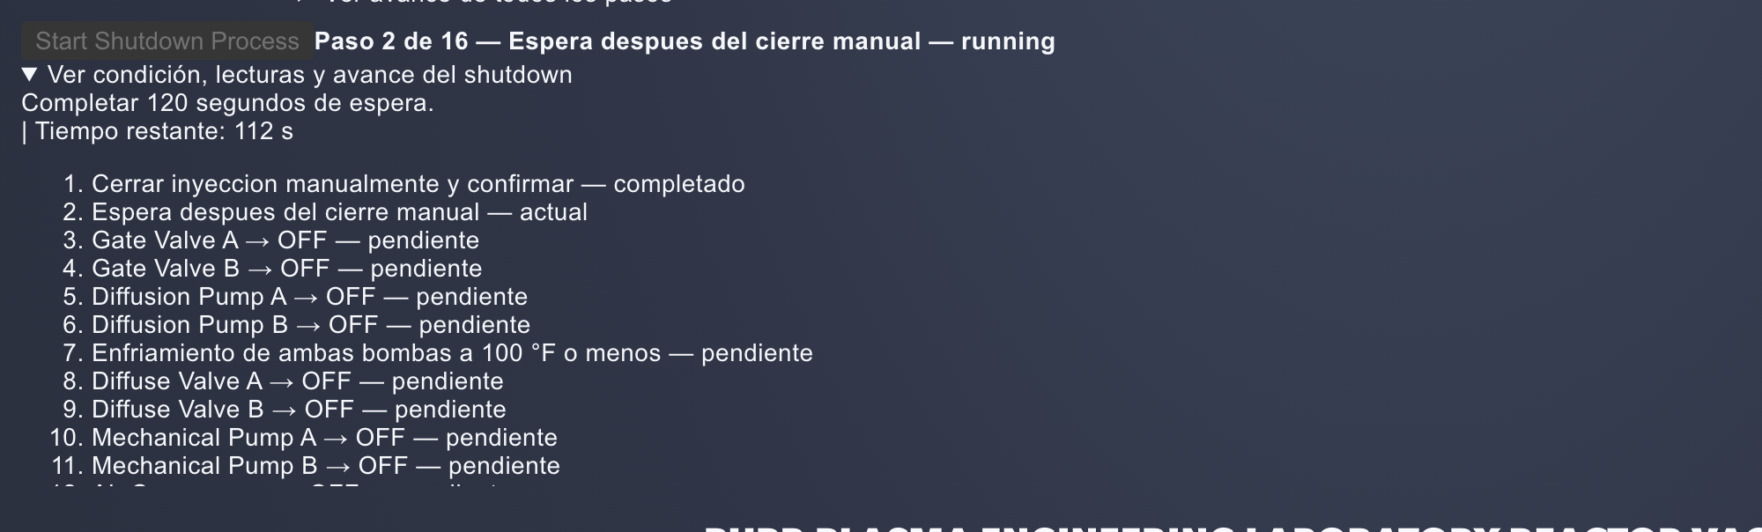
Figure 24. Shutdown in progress: step 2 of 16, 120 s wait and list of steps.
Warning: If a relay command is not confirmed, the Shutdown stops with the message “Orden sin confirmar: secuencia detenida; use Emergency Shutdown” (command not confirmed: sequence stopped; use Emergency Shutdown) and does not retry.

18.2 Normal Shutdown and Emergency
Table 38. Differences between normal Shutdown and Emergency.
Aspect | Normal Shutdown | Emergency
Purpose | Orderly stop of the process | Immediate software stop
Shutdown order | Step by step, with a cool-down wait | All relays at once
Protection of the Diffusion Pumps | Keeps roughing vacuum and cooling until 100 °F | None; it also de-energizes pumps and cooling
Operator confirmation | Manual gas closure | Does not ask for confirmation
Final state | Controls available | Latched until the system is restarted

19. Software Emergency
Figure 25. Emergency bar at rest.
The EMERGENCY SHUTDOWN button is in the top bar of both interfaces (Figure 25). It remains available during the Startup, the Shutdown, the waits and sequence failures. It does not ask for confirmation.

19.1 Stop actions
- Latches the stop in the backend: from that moment on, every manual or sequence command is rejected with STOP_LATCHED.
- Sends a zero setpoint to the mass flow (DAQC2plate 4 / DAC0).
- Sends OFF to each of the 16 relays, even if some command fails.
- Reads both relay boards to confirm that the output mask is zero.
- Shows the result and records it in logs/control.log.
Figure 26. Emergency active and confirmed: “PARO ACTIVADO. Relés OFF y consigna cero confirmados en las placas” (stop activated; relays OFF and zero setpoint confirmed on the boards).
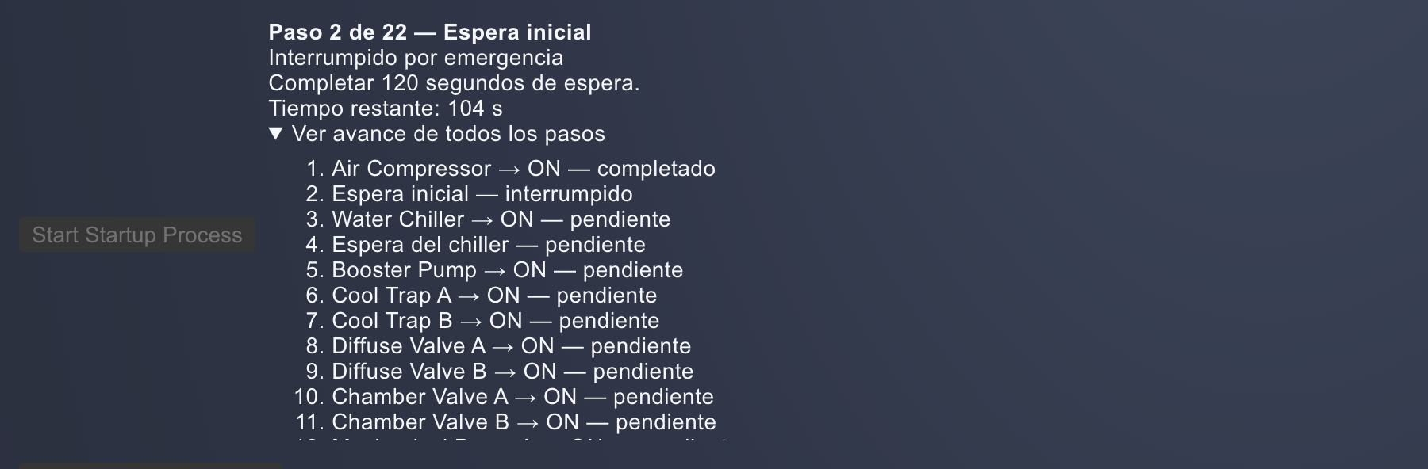
Figure 27. Startup interrupted by an emergency.
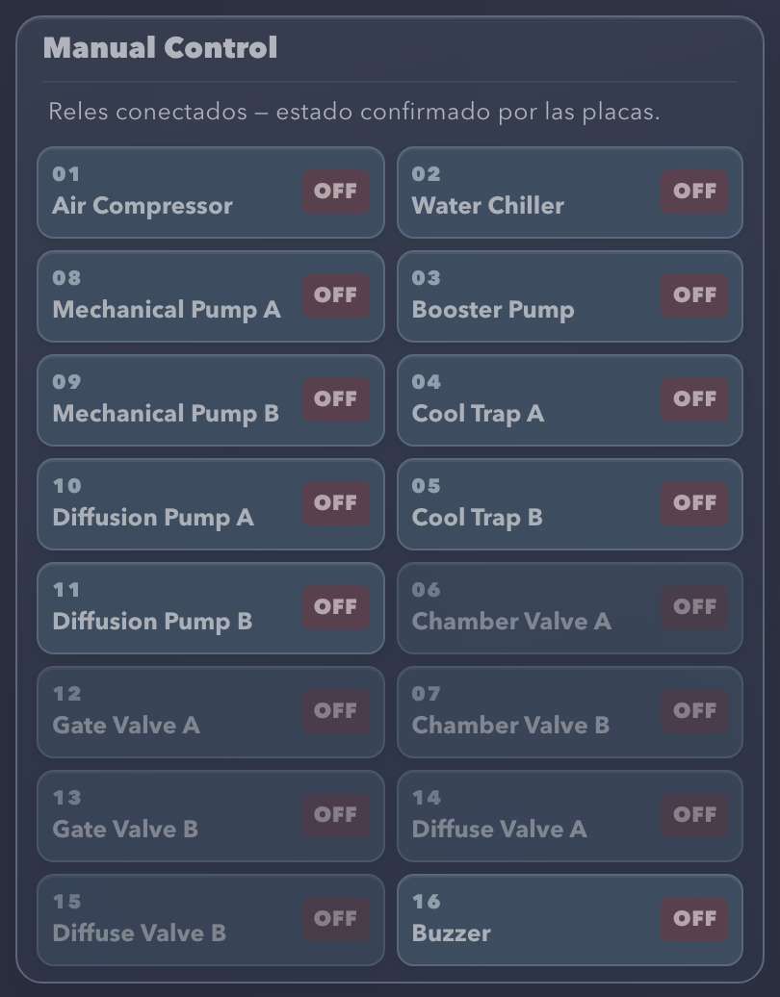
Figure 28. Manual Control after Emergency: all relays OFF and controls locked.
Table 39. Emergency messages.
Message | Meaning
“PARO ACTIVADO. Relés OFF y consigna cero confirmados en las placas. Mandos bloqueados hasta reiniciar main.py.” (stop activated; relays OFF and zero setpoint confirmed; controls locked until main.py is restarted) | All outputs were confirmed off.
“PARO ACTIVADO: hay salidas sin confirmar. Mandos bloqueados.” (stop activated: some outputs not confirmed; controls locked) followed by the list of errors | The stop is latched, but some output or board did not confirm. Check the equipment and use the physical stop.
“NO SE PUDO CONFIRMAR EL PARO…” (the stop could not be confirmed) | Communication error when sending the command; the command may have arrived. Use the physical stop.
“Sin conexión con el paro…” (no connection with the stop) | The interface cannot communicate with the backend.

After the stop, the button changes to REINTENTAR APAGADO (retry shutdown), which repeats the shutdown attempt (Figure 26). The Startup or Shutdown in progress changes to “Interrumpido por emergencia” (interrupted by emergency) (Figure 27) and Manual Control stays locked with all relays OFF (Figure 28). The latch cannot be reset from the browser: to operate again, stop the system with Ctrl+C and run npm start again. Restarting does not turn any output on.
Figure 29. The same Emergency state in the Reactor Dashboard.
Note: The Emergency bar messages mention main.py. In this version, main.py is started by npm start; restarting main.py means stopping and starting the system again.

19.2 Scope of the software stop
- Stopping the system with Ctrl+C, SIGTERM or SIGHUP also runs the stop (section 23).
- Closing a browser tab does not stop main.py or run the stop.
- A power outage or forced termination (kill -9, SIGKILL) prevents the stop from running.
- OFF means relay de-energized. Zero on DAC0 is a zero setpoint; it does not confirm the mechanical closure of the Aera or gas isolation.
- The stop also de-energizes pumps and cooling, without a cool-down wait.
Warning: The software stop does not replace an independent physical stop of the reactor. Keep the physical stop accessible at all times.
Physical validation pending: Verify with the equipment that Emergency de-energizes the 16 outputs and that the Aera zero setpoint produces the expected behavior.

20. Diagnostics and error handling

20.1 Where errors appear
Table 40. Location of error messages.
Location | Contents
Vacuum Controller | Message in the affected panel: “Sin lectura” (no reading) or “Sin estado confirmado” (no confirmed state); details in “Estado de temperaturas”, “Estado de presiones”, “Ultimo error” or below the charts and bars; reason on hover.
Reactor Dashboard | Top bar and Diagnostics box.
Terminal | main.py errors, Node-RED notices and one line per HTTP request.
logs/control.log | Persistent technical log (chapter 21).

Backend messages follow the format [CÓDIGO] mensaje | contexto | Detalle: … | Que revisar: … ([CODE] message | context | Detail: … | What to check: …). The context identifies the equipment, the board (address) and the channel.
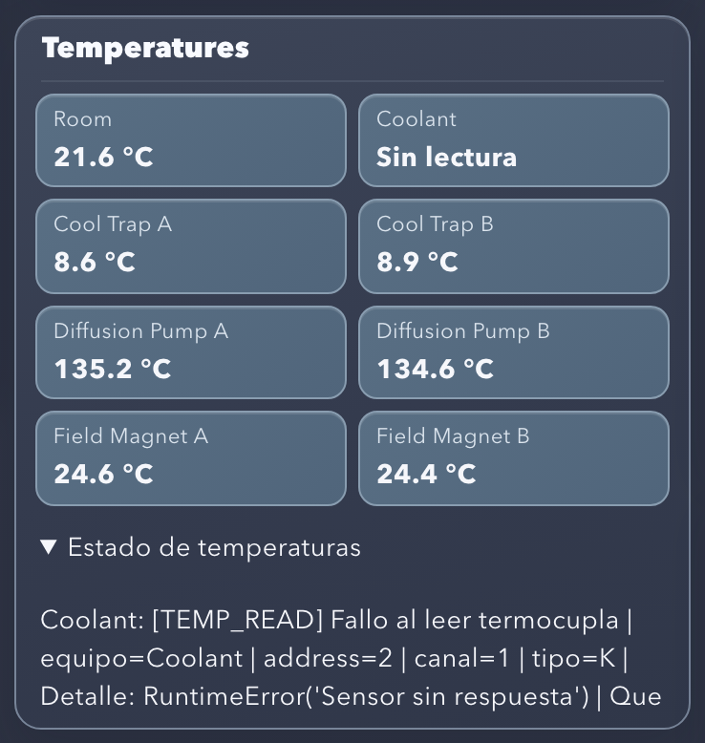
Figure 30. Coolant thermocouple not responding: “Sin lectura” (no reading) and TEMP_READ error with its context.
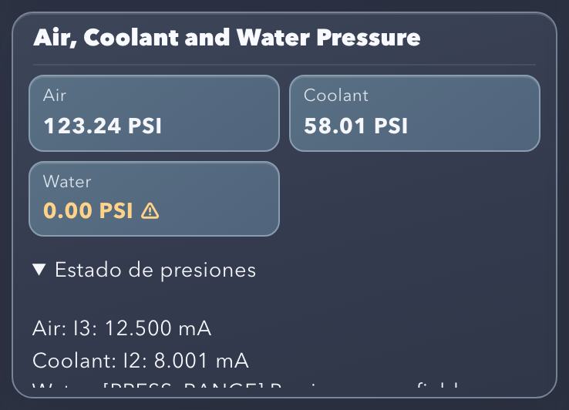
Figure 31. Water Pressure with current outside 4–20 mA: value in yellow with the warning symbol (PRESS_RANGE).
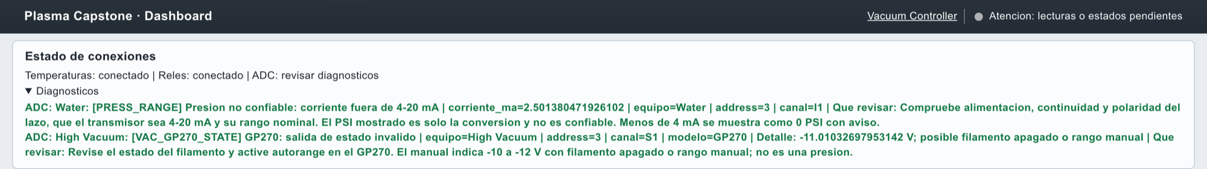
Figure 32. Reactor Dashboard Diagnostics with PRESS_RANGE and VAC_GP270_STATE.
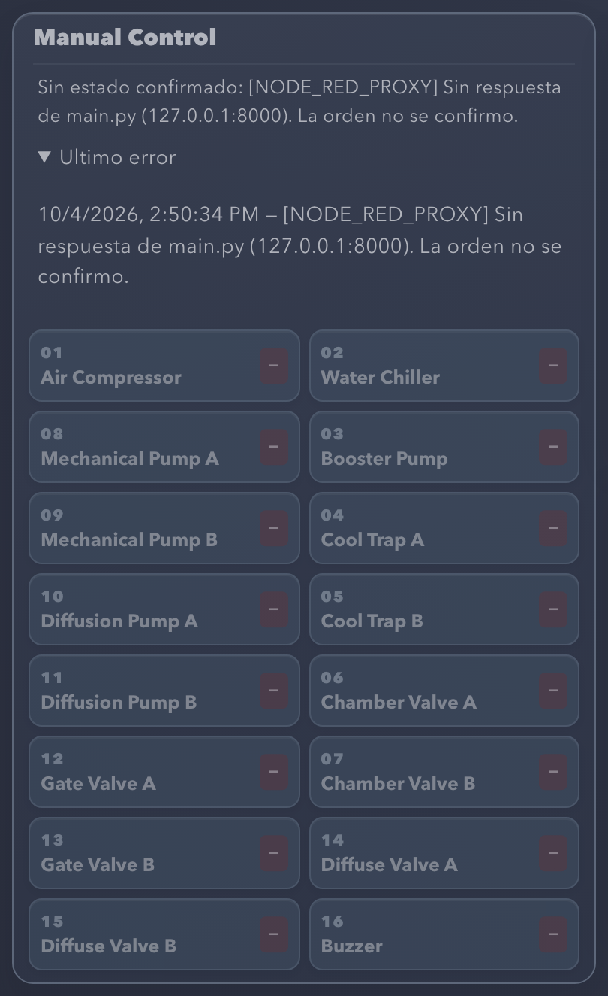
Figure 33. Manual Control with the backend stopped: NODE_RED_PROXY, “La orden no se confirmo” (the command was not confirmed) and relays in unknown state.
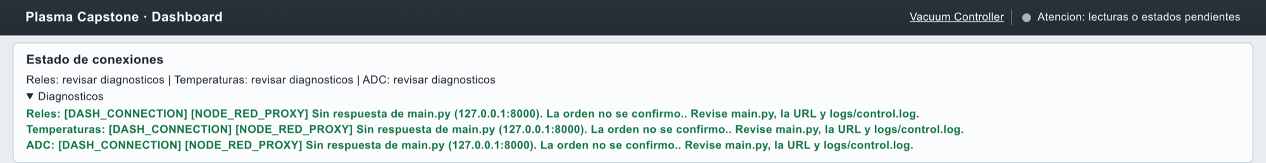
Figure 34. Reactor Dashboard with the backend stopped.
Figures 30 to 34 show real examples of how errors are presented.

20.2 Error codes
Table 41. System error codes.
Code | Meaning | Interface behavior | What to check
HW_IMPORT | The Pi-Plates library could not be loaded. | main.py does not start; the system stops. | Pi-Plates installed in the Python that runs main.py (section 5.4).
HW_INIT | Failure initializing Pi-Plates. | main.py does not start. | SPI enabled, permissions and GPIO driver compatibility.
HW_ID | A RELAYplate2 cannot be identified at its address. | main.py does not start. | With the equipment off: stack mounting, address jumpers, power and SPI.
HW_READ | A relay board could not be read. | Relays in unknown state. | Power and SPI connection; permissions of /dev/spidev*.
HW_STATE | Invalid relay mask. | Relays in unknown state. | Communication and Pi-Plates version; do not interpret as OFF.
HW_WRITE | Failure sending a relay command. | Uncertain command; not retried. | Actual state of the equipment before repeating.
HW_CONFIRM | The command was sent but not confirmed. | Uncertain command; not retried. | Equipment and board state; the relay may have changed.
TEMP_IMPORT, TEMP_ID, TEMP_CONFIG, TEMP_INIT | Library, identification or configuration failure of the THERMOplate. | All temperatures “Sin lectura” (no reading); retry every 5 s. | Pi-Plates, SPI, power and address 2 jumpers.
TEMP_READ | Failure reading a channel (includes Room). | That channel “Sin lectura” (no reading). | Terminals, polarity, continuity and probe type; for Room, the DS18B20 on port 9.
TEMP_VALUE | Non-numeric value. | That channel “Sin lectura” (no reading). | Open sensor, polarity, type and connection.
TEMP_RANGE | Value outside the conversion range (K: −200 to 1372 °C; Room: −55 to 125 °C). | That channel “Sin lectura” (no reading). | Type, polarity and terminals. It is not a process alarm.
WATER_TEMP_READ, WATER_TEMP_VALUE | Failure or invalid value on I0. | Water Temp “Sin lectura” (no reading). | ADCplate 3 / I0, power and transmitter loop.
WATER_TEMP_RANGE | Current outside 4–20 mA. | Water Temp “Sin lectura” (no reading). | Transmitter, power and loop.
PRESS_INIT | The ADCplate could not be initialized. | Pressures, water, vacuum and Rough without reading; retry every 5 s. | Pi-Plates, SPI, power and address 3 jumpers.
PRESS_READ, PRESS_VALUE | Failure or invalid current value. | That pressure “Sin lectura” (no reading). | Communication, channel and transmitter loop.
PRESS_RANGE | Current outside 4–20 mA. | Value in yellow with a warning symbol (not reliable). | Power, continuity, polarity and range of the transmitter.
VAC_TN906_STATE | Terranova in LO (0 V), OFF/HI (≈3 V) or out of range. | Medium shows the voltage and the error; dotted line. | Terranova panel, analog output and S0.
VAC_GP270_STATE | GP270 between −12 and −10 V. | High shows the voltage and the error; dotted line. | GP270 filament and autorange.
VAC_GP270_RANGE | Voltage outside 0 to −5 V. | Same. | GP270 Pressure output, return and S1.
VAC_GP270_ZERO | 0 V output. | Same; zero Torr is not shown. | Controller, filament, autorange and wiring.
VAC_READ, VAC_VALUE, VAC_RANGE | Read failure, invalid value or non-representable result. | Same. | ADCplate 3, S channel, controller power.
ROUGH_READ, ROUGH_VALUE, ROUGH_RANGE | Failure, invalid value or voltage outside 0–10 V on S4/S5. | Bar shows “Sin lectura” (no reading). | Sensor cable, common and power (chapter 14).
STARTUP_LOCKED, SHUTDOWN_LOCKED | Manual command during a sequence. | Command rejected. | Wait for the sequence to end; Emergency remains available.
STARTUP_STATE, SHUTDOWN_STATE | Action not valid in the current sequence state. | Command rejected. | Sequence state; each one runs once per start.
STOP_LATCHED | Stop latched. | Every command rejected. | Check the equipment and restart the system.
INPUT | Invalid or disallowed command (includes the permissions in section 12). | Command rejected with the reason. | Conditions indicated in the message.
MFC_DAC, MFC_WRITE | Failure writing or reading DAC0. | Appears in the Emergency result. | DAQC2plate 4 and DAC0.
MFC_INPUT, MFC_READ | Reserved for the mass flow. | Do not appear in normal operation. | Not applicable
AUTO_TRANSFER, AUTO_SENSOR, AUTO_CONFIG, AUTO_VALUE | Reserved for Automatic Vacuum. | Do not appear in normal operation. | Not applicable
SERVER_BIND | main.py could not open port 8000. | main.py does not start. | Another instance using the port (section 5.7).
HTTP_ORIGIN, HTTP_TYPE, HTTP_ROUTE | Request with a disallowed origin, format or route. | Request rejected. | Use the Node-RED interfaces.
GUI_FILE, BROWSER | Pages and browser opening served by main.py. | Not applicable to operation with Node-RED. | Not applicable
INTERNAL | Unexpected backend error. | Message with the details. | Terminal and logs/control.log; do not assume the command failed without checking the relay.
NODE_RED_PROXY | Node-RED got no response from main.py (HTTP 502). | “La orden no se confirmo” (the command was not confirmed); relays unknown. | That main.py is running (terminal).
NET_TIMEOUT | No response within 5 s to a manual command. | Command not resent. | Equipment state before repeating.
NET_CONNECTION, NET_RESPONSE | No connection or invalid response. | Relays unknown. | That the system is running and the URL is the Node-RED one.
TEMP_CONNECTION, PRESS_CONNECTION, DASH_CONNECTION | Backend timestamp has not advanced for more than 15 s, or no connection. | “Sin lectura” (no reading) in the corresponding area. | System running and terminal.

21. Technical logs
main.py writes a technical log to logs/control.log, inside the Node-RED final folder.
Table 42. Technical log characteristics.
Characteristic | Value
Location | Node-RED final/logs/control.log
Rotation | At 1 MB it is renamed and 3 previous files are kept (control.log.1 to control.log.3).
Level | INFO and above
Events recorded | Sensor and board errors, reading recoveries, activation and return to normal of the Room alarm, results of Emergency and of main.py shutdown, and API errors.
If it cannot be written | main.py warns in the terminal and diagnostics continue in the terminal only.

cd "$HOME/Desktop/Node-RED final"
tail -f logs/control.log
Example entry when closing the system: WARNING Paro: {'reason': 'Cierre de main.py', 'confirmed': True, 'errors': {}}.
Note: The technical log is for diagnostics. It is not a database of experimental measurements. HTTP request lines appear only in the terminal.

22. Functions reserved for future work
Three areas of the Vacuum Controller keep their design but are disabled. They show the orange text “No habilitado — próximamente para grupos futuros” (not enabled; coming for future groups) and their controls do not respond.
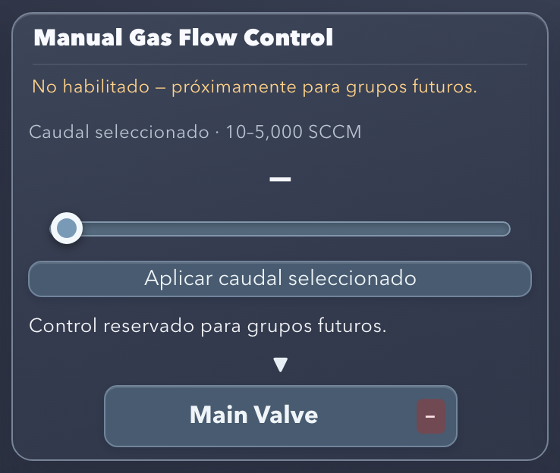
Figure 35. Manual Gas Flow Control (reserved).
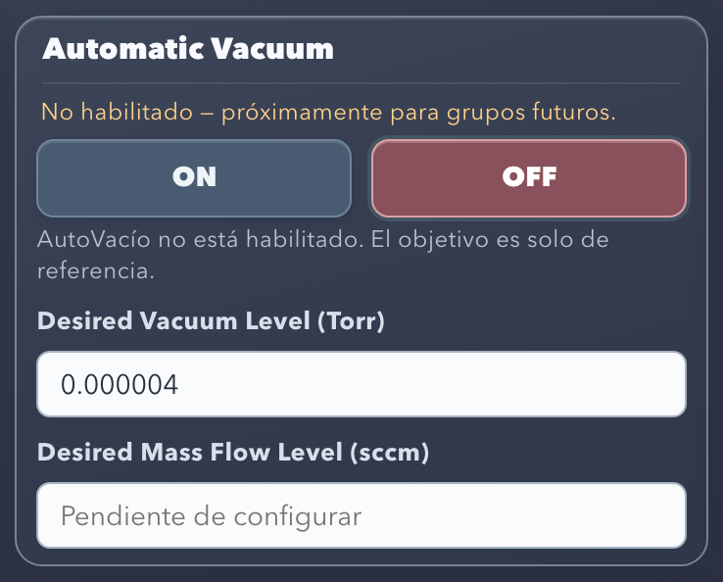
Figure 36. Automatic Vacuum (reserved).
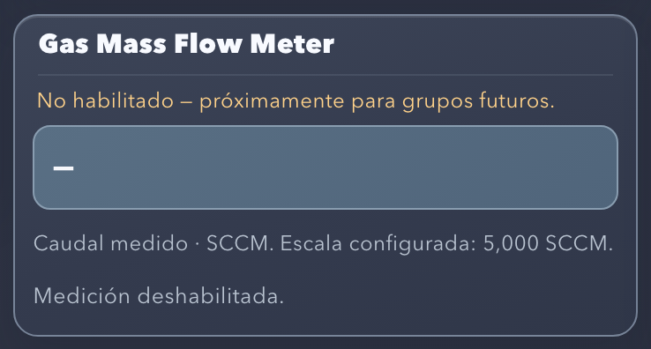
Figure 37. Gas Mass Flow Meter (reserved).
Table 43. Reserved functions.
Function | Status in this delivery
Manual Gas Flow Control (Figure 35) | Disabled. GET and POST /api/mass-flow are rejected. DAC0 is set to zero only during Emergency.
Automatic Vacuum (Figure 36) | Disabled. “Desired Vacuum Level” is for reference only; there is no automatic cycle.
Gas Mass Flow Meter (Figure 37) | Disabled. The reserved input S6 is not read.

Note: Vacuum Levels is not a future function: it shows the Roughing Vacuum Gauges A/B in operation (chapter 14).

23. Shutting down the software correctly
Warning: Closing the software immediately turns off the 16 relays, including the pumps and cooling. To stop the process in an orderly way, first run the normal Shutdown (chapter 18), wait for Shutdown normal completado (normal shutdown completed) and then close the software.
- In the terminal where npm start was run, press Ctrl+C once.
- main.py runs the software stop: zero setpoint on DAC0 and OFF on the 16 relays, with confirmation from the boards.
- The two Node-RED instances stop their flows.
- launch.js waits up to 15 s for the three processes to finish and returns to the terminal prompt.
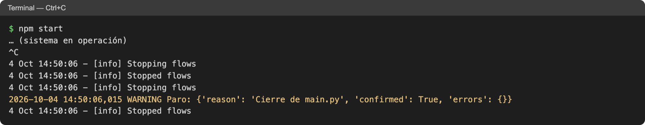
Figure 38. Terminal output when stopping the system with Ctrl+C: stop confirmed and flows stopped.
- Closing the terminal window also stops the system and runs the stop (SIGHUP signal). Use Ctrl+C as the normal method.
- Closing the browser or a tab does not stop the system.
- Do not use kill -9: it prevents the software stop.

24. Troubleshooting
Table 44. Common problems.
Symptom | Probable cause | Action
node: command not found or npm: command not found | Node.js not installed. | Section 5.3.
node -v lower than v18 | Old version of Node.js. | Install Node.js 22 from NodeSource (section 5.3).
npm ci fails | No internet, or package-lock.json is missing. | Check the network and that it runs inside Node-RED final; repeat npm ci.
HW_IMPORT at startup | Pi-Plates not installed in that Python. | Section 5.4; with a virtual environment: PYTHON=/path/venv/bin/python3 npm start.
HW_INIT or SPI errors | SPI disabled. | In sudo raspi-config, go to Interface Options, then SPI, and select Enable; reboot.
HW_ID | Board not responding at its address. | With the equipment off: stack, jumpers, power.
EADDRINUSE, Address already in use or SERVER_BIND | Another program is using 8000, 1880 or 1881. | ss -ltnp | grep -E ':(8000|1880|1881) '; close the other instance or run sudo systemctl stop nodered.
main.py termino (codigo 1); cerrando todo. | The backend failed at startup. | Read the error immediately above in the terminal.
The interfaces open but everything says “Sin lectura” (no reading) or NODE_RED_PROXY | main.py does not respond. | Check the terminal; restart with Ctrl+C and npm start.
The interface does not open in the browser | System stopped, wrong URL or SSH tunnel closed. | Confirm that npm start is running and use the URLs in section 7.
127.0.0.1:8000 or an .html file was opened | It is not the official interface. | Use http://127.0.0.1:1880/dashboard/main.
A button does not allow ON | Permission rule not met or sequence in progress. | Hover over the button and meet what it indicates (section 12).
Relay in “—” state | No confirmation from the boards. | Check “Ultimo error” (last error), RELAYplate2 power and the terminal.
Temperature “Sin lectura” (no reading) | Disconnected channel, polarity or THERMOplate. | See “Estado de temperaturas” and the error code table.
Pressure “Sin lectura” (no reading) or in yellow | 4–20 mA loop open or out of range. | See “Estado de presiones”; check transmitter and loop.
Rough “Sin lectura” (no reading) | S4/S5 disconnected or outside 0–10 V. | Chapter 14.
Room alarm active | Room > 29 °C. | Check the laboratory air conditioning; silence it by turning off the Buzzer. It deactivates at ≤ 28 °C.
Emergency active | Stop latched. | Check the equipment; Ctrl+C and npm start.

25. Verification and validation status
Table 45 distinguishes what is implemented and tested in software from what requires physical validation with the reactor.
Table 45. Validation status by component.
Component | Implemented and tested in software | Physical validation pending
Manual control and permissions | Rules for each relay, exact limits, stale or invalid readings, OFF always allowed; complete path through Node-RED. | Match between each command and the equipment response.
Startup | Complete sequence, waits, conditions, locks, gas confirmation and Emergency. | Run with the reactor, real times and temperatures.
Normal Shutdown | Complete sequence, 120 s wait, cool-down to 100 °F, locks. | Run with the reactor.
Emergency | Attempt on all 16 outputs, zero setpoint, continuation on failures, subsequent rejection. | Actual switch-off of the outputs and response of the Aera.
Room and alarm | Port 9 reading, 29/28 °C thresholds, Buzzer, sensor failure and Emergency. | DS18B20 against a reference thermometer; audible Buzzer.
Rough A/B | S4/S5; 2.5 V gives 25 % and 7.5 V gives 75 %; tolerance and errors. | S4/S5 wiring with their common; voltage against the sensor output.
Thermocouples | Reading, conversion range and errors per channel. | Type K and polarity of each probe.
Water Temperature | 4–20 mA formula and out-of-range rejection. | Comparison with a physical reference.
Pressures | Formula and warning outside 4–20 mA. | 0–232 PSI scale of the installed transmitters.
Medium / High Vacuum | Formulas, invalid states and charts. | Comparison with the panels; GP270 decade changes.
Node-RED | Two instances, proxy, HTTP 502, interfaces without console errors. | Presentation on the Raspberry Pi screen.
Performance | Not applicable | Latency and resource usage on the 4 GB Raspberry Pi 4.

25.1 Automated tests
The tests/ folder contains 54 Python unit tests and two JavaScript tests. The Python tests use test doubles and do not require hardware.
cd "$HOME/Desktop/Node-RED final"
python3 -m unittest discover -s tests
node tests/test_manual_polling.cjs
node tests/test_nodered.cjs # with npm start running; read-only
Note: tests/test_nodered.cjs only queries the state (it does not send commands), so it can be run with the reactor connected.

26. Quick reference
- Power on the Raspberry Pi and the Pi-Plates power supplies.
- Open Terminal.
- cd "$HOME/Desktop/Node-RED final"
- npm start
- Confirm: http://127.0.0.1:8000 | Control de reles conectado.
- Confirm: NODE-RED vacuum: …1880… and NODE-RED dashboard: …1881….
- Open the Vacuum Controller: http://127.0.0.1:1880/dashboard/main.
- Open the Reactor Dashboard: http://127.0.0.1:1881/dashboard/main.
- Check for Reles conectados and Monitor conectado, or check Diagnostics.
- Operate according to this manual: Startup (chapter 17), manual control (chapters 11–12) and Shutdown (chapter 18).
- When finished, press Ctrl+C in the terminal for an orderly shutdown.
Table 46. Main buttons.
Button | Location | Function
EMERGENCY SHUTDOWN | Both interfaces, top bar | Immediate, latched software stop.
Start Startup Process | Vacuum Controller | Starts the Startup sequence.
Gas ajustado manualmente — confirmar | Vacuum Controller | Finishes the Startup.
Start Shutdown Process | Vacuum Controller | Starts the normal Shutdown.
Válvula de inyección cerrada manualmente — confirmar | Vacuum Controller | Confirms the gas closure and continues the Shutdown.

27. Appendices

Appendix A. Backend API
The interfaces use these routes through the Node-RED proxy. All of them respond with JSON.
Table 47. API routes.
Method and route | Use
GET /api/relays | State of the 16 relays, manual permission and reason.
POST /api/relays {"name": "<equipment>", "on": true|false} | Manual command for a relay.
GET /api/temperatures | Thermocouples, Room and alarm state (room_alarm).
GET /api/pressures | Pressures, Water Temperature, Medium/High Vacuum and Rough A/B (rough).
GET /api/startup / POST /api/startup {} | Startup state / start.
POST /api/startup/confirm-gas {} | Gas adjustment confirmation.
GET /api/shutdown / POST /api/shutdown {} | Shutdown state / start.
POST /api/shutdown/confirm-gas {} | Gas closure confirmation.
GET /api/emergency / POST /api/emergency {} | Emergency state / activation.
GET and POST /api/mass-flow | Reserved; they are rejected.

Appendix B. Folder structure
Table 48. Main files of Node-RED final.
File or folder | Contents
package.json, package-lock.json | Dependencies and the npm start command.
launch.js | Launcher of the three processes.
server.js | Node-RED instance (vacuum or dashboard).
flows.json | Template of the /api/* proxy.
flows-vacuum.json, flows-dashboard.json | Flows of each instance.
build_dashboards.py | Regenerates the flows from the HTML/JS screens.
vacuum_controller.html, dashboard.html and .js files | Source of the screens.
main.py and .py modules | Backend (module table, section 3.5).
tests/ | Automated tests.
logs/ | Technical log (created at startup).
.runtime/ | Internal data of each Node-RED instance (created at startup).
node_modules/ | Node-RED and dependencies (created with npm ci).

Appendix C. Environment variables
Table 49. npm start environment variables.
Variable | Effect
PYTHON | Python interpreter for main.py (default python3). Useful with a virtual environment.
NO_BROWSER=1 | Does not open the browser at startup.
VACUUM_PORT, DASHBOARD_PORT | Change the ports of the Node-RED instances. The links between interfaces use 1880 and 1881; use the default values in operation.

Appendix D. Glossary
Table 50. Glossary.
Term | Definition
Backend | The main.py process, which controls the hardware and serves the API.
Latched | State that is kept until the system is restarted, such as Emergency.
Node-RED instance | Independent Node-RED process with its own port and flows.
Proxy | Node-RED flow that forwards /api/* to main.py.
Confirmed relay | State read from the board after the command.
ui-template | FlowFuse Dashboard 2 node that contains a screen in HTML, CSS and JavaScript.
Hysteresis | Difference between the activation threshold (29 °C) and the deactivation threshold (28 °C) of the Room alarm.

Appendix E. Maintaining the screens
Each screen is in a ui-template node of its instance. There are two ways to modify it; use only one so that no changes are lost:
- From the Node-RED editor: open /red, double-click the “Vacuum Controller (HTML/CSS/JS)” or “Reactor Dashboard (HTML/CSS/JS)” node, edit it and press Deploy. The changes are saved in flows-vacuum.json or flows-dashboard.json.
- From the source files: edit vacuum_controller.html, dashboard.html or their .js files and run python3 build_dashboards.py. This command replaces what was edited in the Node-RED editor.
Warning: The safety rules are in Python. Modifying a screen does not change the permissions or the sequences.

